

|  |  |
| --- | --- |
| Module code and name: | Distributed Systems and Cloud Computing  6BUIS014C-n |
| Assessment: | CW 1 |
| Lecturer Name | Isomiddin Abdunabiev |
| Student ID: | 00010983 |
| Submission deadline: | 07.11.2023 |
| Wordcount | 2532 |
| Results date and type of feedback |  |
| Result (Pass or Fail) |  |
| **Feedback** | |
|  | |

# 

**Introduction 4**

**GANTT’s Chart 5**

**Models Structure in MVC 7**

**Screenshots of MVC with CRUD Requests to API (5%) 8**

Viewing 8

Creating 9

Modifying 10

Deleting 11

**Microservice API and DB Instances 14**

API Models Structure 14

CRUD Operations 14

Customer 14

Creating 14

Reading 15

Updating 18

Deleting 20

Ticket 21

Creating 21

Reading 22

Updating 25

Deleting 27

Package Version Information 28

Database Migrations 29

Stand-alone SQL File with Insert Statements 30

Database Structure Diagram 33

Screenshots of the Database with Inserted Items 34

**Version controlling (GitHub). 36**

Project Repository 36

API Repository 38

Frontend (MVC) Repository 38

**Hosting and Code Deploy. 39**

Code Deploy Service Role 39

Database Server Setup 41

Linux Instance Setup 45

Microsoft Instance Setup 55

**Conclusion 63**

# 

# **Introduction**

This report outlines the development and deployment of a web application with a MVC frontend and microservice API backend. The key goals were to implement CRUD operations through API endpoints, build an intuitive UI, and deploy the application via AWS. The report details the planning, development, testing, and deployment phases, highlighting the technologies used. It provides code samples, diagrams, and screenshots to illustrate the application architecture and workflow. Overall, this report offers insights into the methodical approach taken to build and deploy a cloud-based full-stack application.

Below are the links for the project:

1. Linux API Instance: [http://](https://github.com/00010983/CW_DSCC_10983)ec2-16-16-187-56.eu-north-1.compute.amazonaws.com
2. Windows MVC Instance: [http://](https://github.com/00010983/CW_DSCC_10983)ec2-16-16-187-56.eu-north-1.compute.amazonaws.com
3. GitHub Project Repo: <https://github.com/00010983/CW_DSCC_10983>
4. GitHub MVC Repo: <https://github.com/00010983/MVC_00010983>
5. GitHub API Repo: <https://github.com/00010983/API_00010983>

# GANTT’s Chart

Throughout this coursework, I independently undertook various tasks, and the Gantt chart played a pivotal role in structuring my project plan. It allowed me to efficiently manage a series of complex tasks. The chart provided a clear visual representation of the project's timeline and task dependencies, guiding me through the following key phases:

1. Planning (Oct 28 - Oct 29): This initial phase was crucial for defining the project's scope and objectives.
2. Front-end (MVC) and API Development (Oct 29 - Nov 4): These phases formed the core of the project, focusing on the concurrent development of the MVC front-end and microservice API.
3. Database Setup (Oct 31 - Nov 1): Establishing a robust data storage infrastructure was fundamental for the project's success.
4. GitHub Repository (Oct 29 - Nov 6): This phase facilitated version control and documentation, ensuring a secure and organized project repository.
5. Report (Oct 31 - Nov 7): Summarizing the project's development process and reflecting on the Gantt chart's role in project management was a critical step.
6. Instances Setup, Code Deploy, and Public Testing (Nov 5 - Nov 7): These final stages were essential for deploying and testing the application, ensuring its readiness for public use.

The Gantt chart was an indispensable tool that allowed me to maintain a well-structured and organized approach to this coursework.

# 

# Models Structure in MVC

The Customer class within my MVC project functions as the model component, which serves as the model for the project. It encompasses essential fields such as the primary key (PK) CustomerId, Name, DateOfBirth, Email, PhoneNumber, and Address.

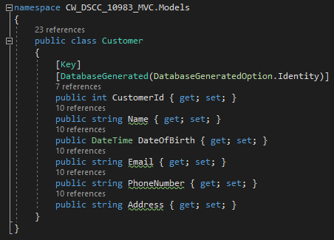

The Ticket class within my MVC project functions as the model component. It plays a pivotal role in the system by serving as a representation of a customer's ticket. This class is characterized by essential attributes, including a foreign key (FK) relationship with the CustomerId from the Customer class. It effectively links each ticket to a specific customer based on their unique identifier. Key properties of the Ticket class include the following: Title, Departure, Arrival, priority, DueDate, Duration. By encapsulating these properties, the Ticket class serves as a vital component in the project, facilitating the attachment of tickets to specific CustomerIds and storing essential information related to each ticket.

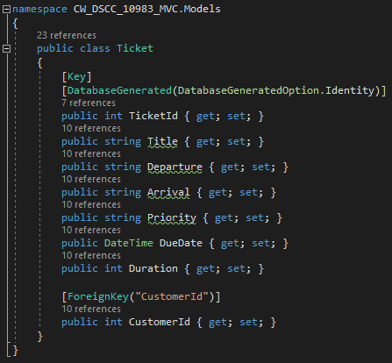

# Screenshots of MVC with CRUD Requests to API (5%)

## Viewing

Users can access the list of customers by navigating to the "Customer" section located at the top of the layout. Within the listing page, users have the capability to select various actions, including creating a new user, making edits, and initiating deletions.

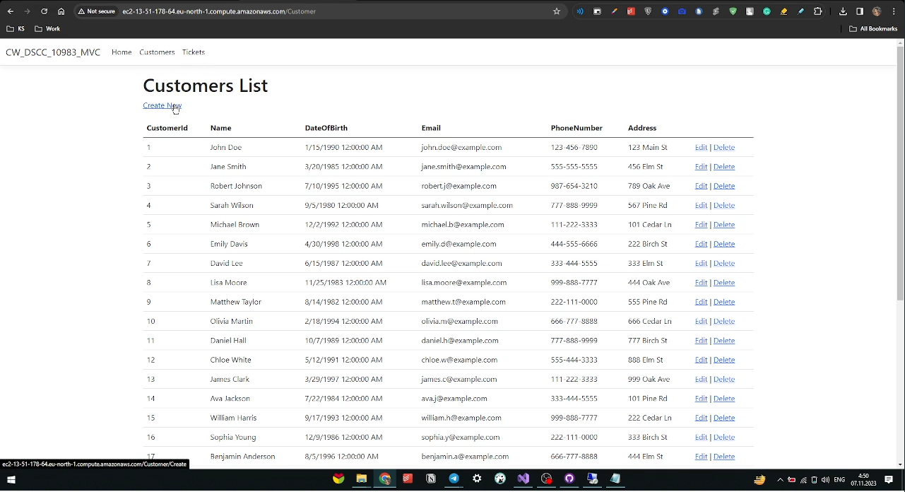

## Creating

Users can initiate the creation of a new customer by clicking on the "Create New" link found on the listing page. They will be prompted to complete all the required fields and subsequently click the "Create" button. It's worth noting that there is a basic validation mechanism in place to ensure that the input fields are not left empty. If the user successfully passes this validation, the creation process will proceed.

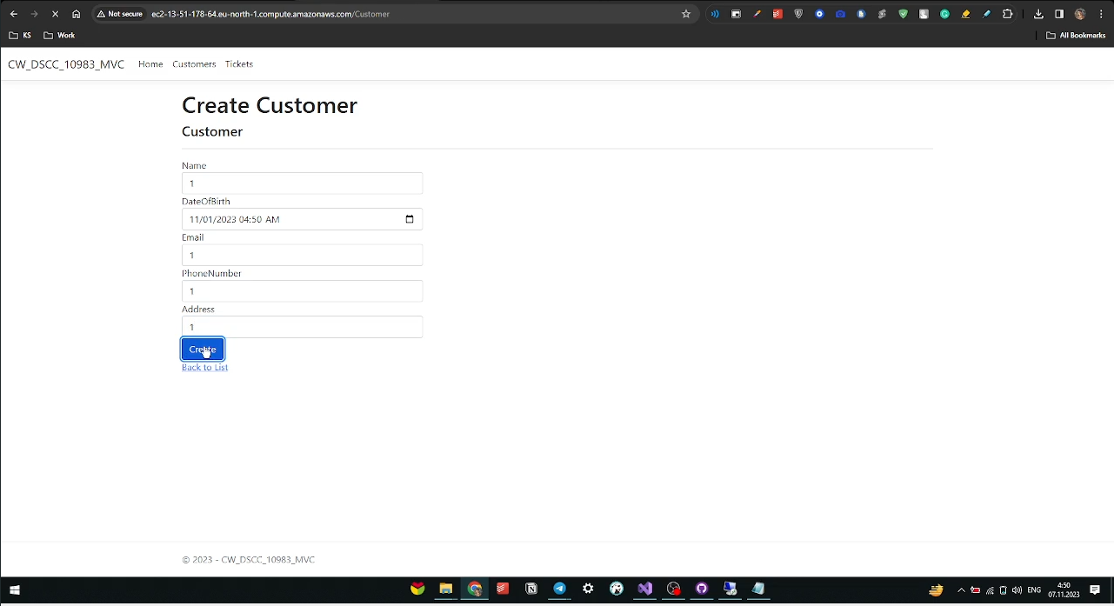

## Modifying

Users have the ability to modify customer information by selecting the "Edit" link associated with the specific customer they wish to edit. This action will redirect the user to an edit page dedicated to the chosen customer. After making the desired changes, users can save their modifications by clicking the "Save" button, thus finalizing the editing process.

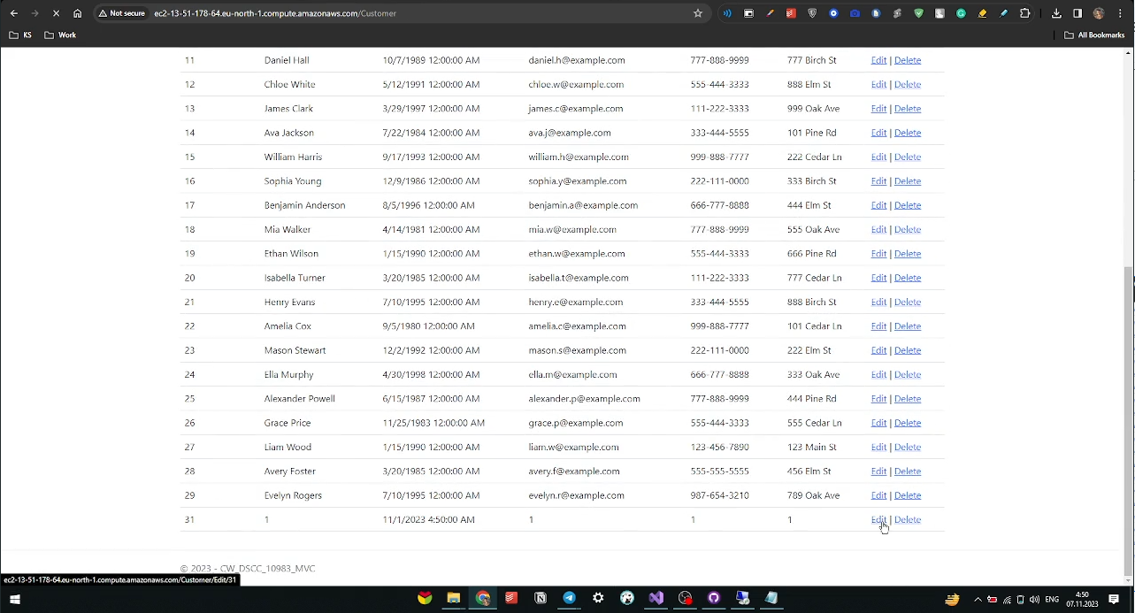

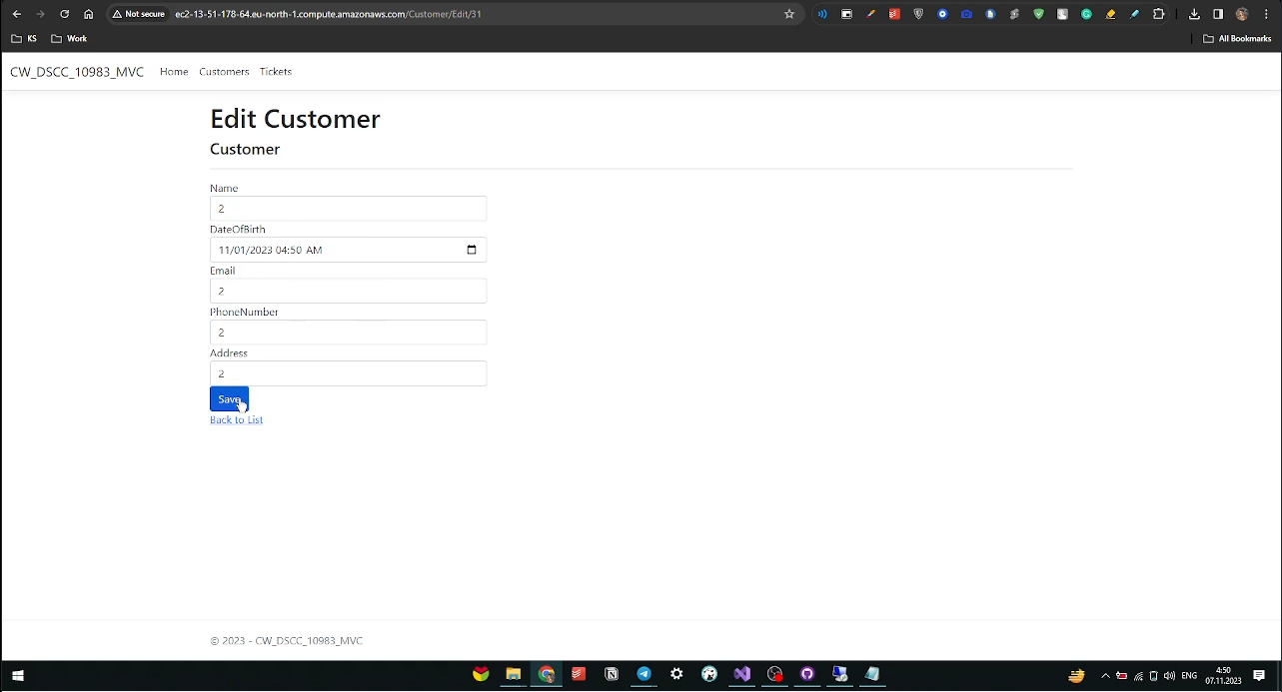

## Deleting

Users can delete a customer by following a similar process as for editing. They should select the "Delete" option for the specific customer they intend to remove. After redirection, they will be able to review the customer details and confirm the deletion by pressing the "Delete" button in a new window, thereby completing the deletion process.

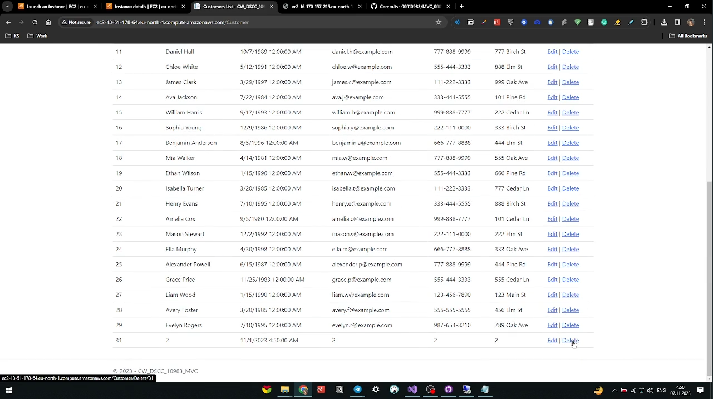

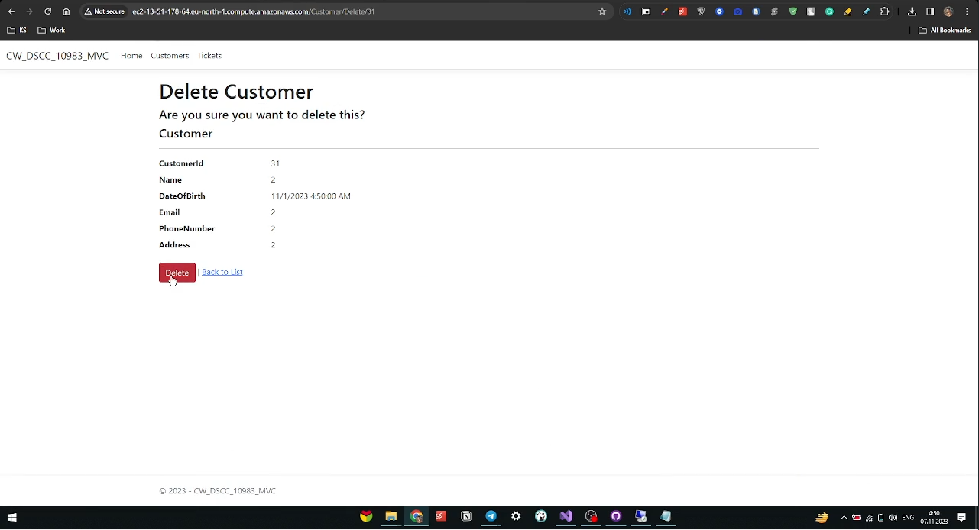

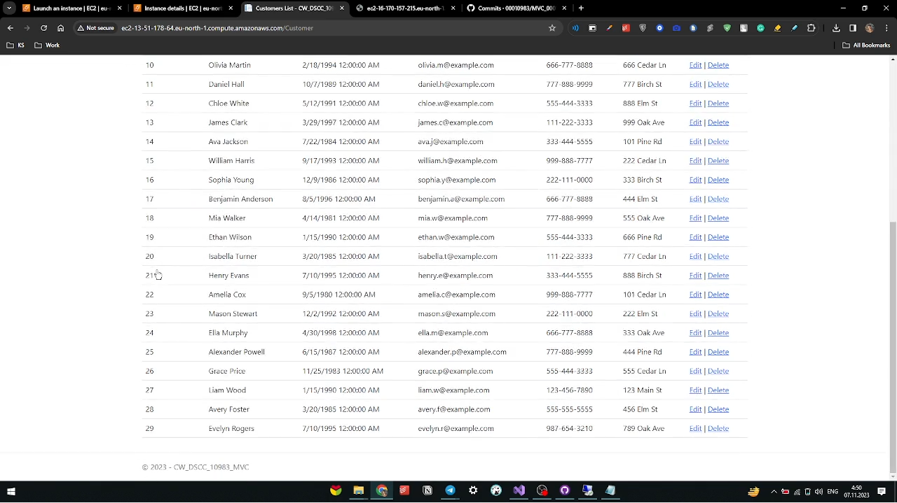

The same logic is applied to the Tickets listing, with the additional validation that ensures a user cannot assign a new or old ticket to a non-existing customer. In other words, the customer must already exist, and this requirement is enforced during the ticket creation or editing process. If the selected customer does not exist, the creation or editing will not proceed.

# Microservice API and DB Instances

## API Models Structure

In the API section of the models, the same logic is applied as in the front-end part. There are two classes, one for Customer and another for Tickets, both of which serve as the encapsulation method.

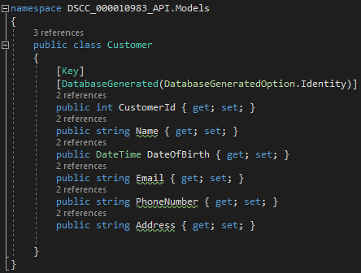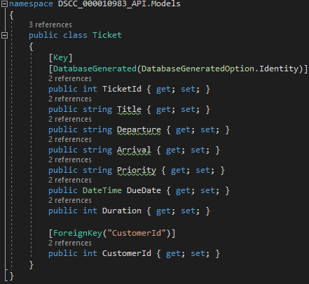

## CRUD Operations

In this section, we will explore API testing using the Postman tool to verify the functionality of our HTTP methods and examine the results they produce. Furthermore, you will find well-commented code within the API methods to facilitate a better understanding of the code's purpose and functionality.

### Customer

#### Creating

POST: to create the new customer.

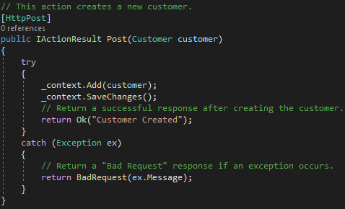

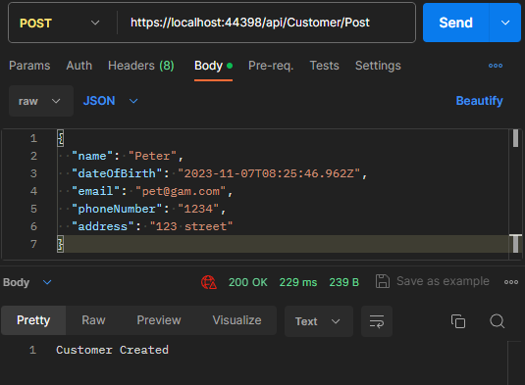

#### Reading

GET: to retrieve all existing customers

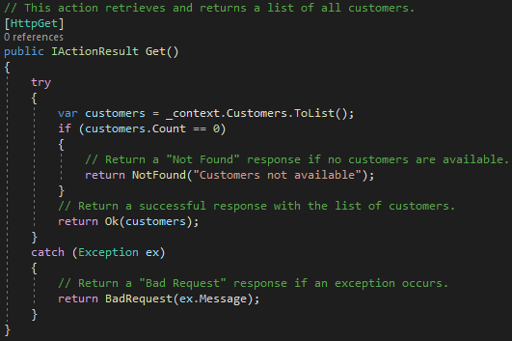

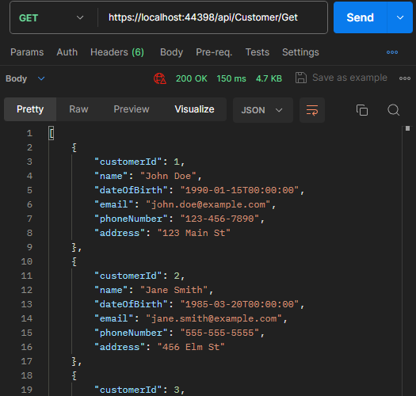

GET by ID: to retrieve customer by ID

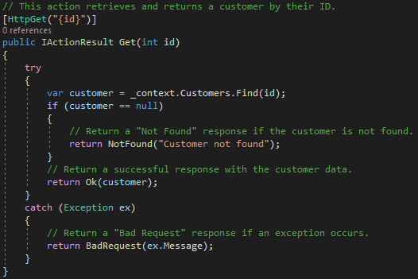

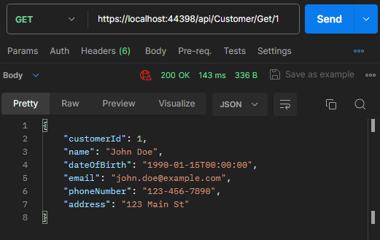

#### Updating

PUT: to edit the existing customer with “new details”.

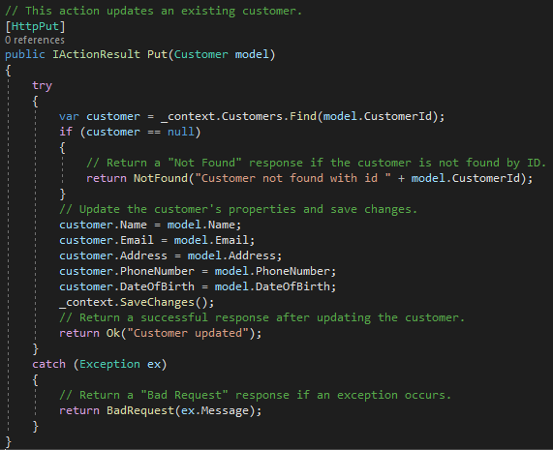

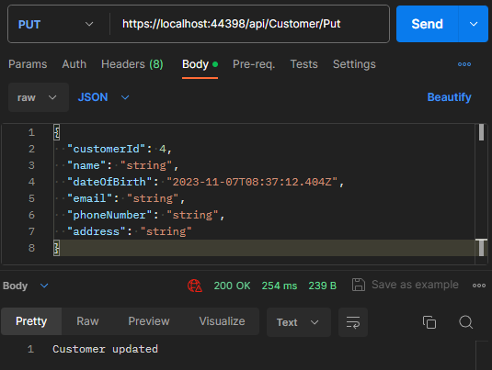

#### Deleting

DELETE by ID: to delete the customer by ID

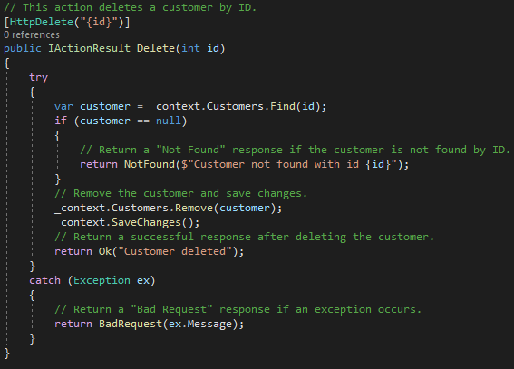

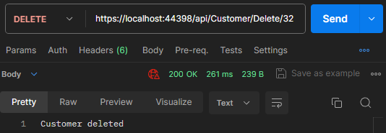

### Ticket

#### Creating

POST: to create the new ticket to the existing customer.

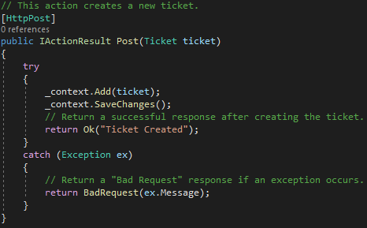

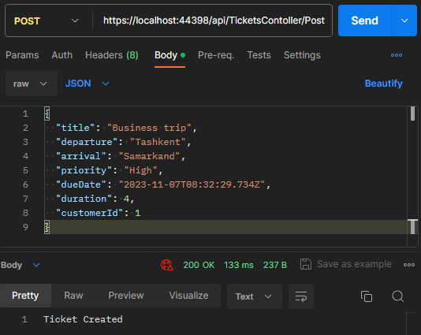

#### Reading

GET: to retrieve all existing tickets

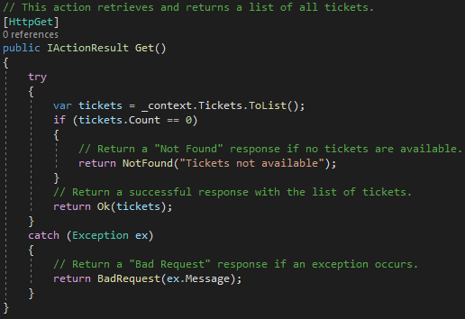

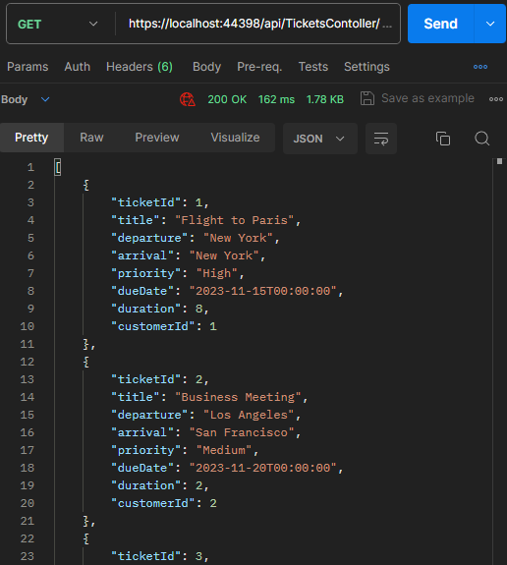

GET by ID: to retrieve ticket by ID

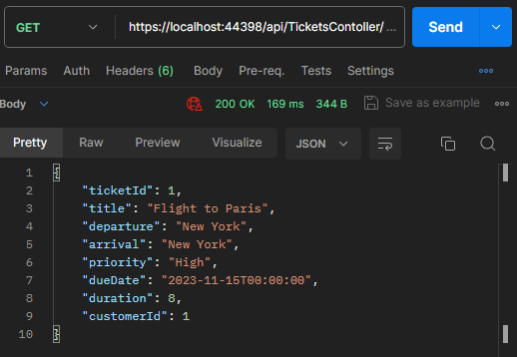

#### Updating

PUT: to edit the existing ticket with “new details”.

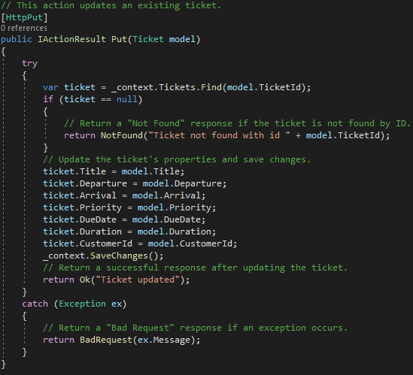

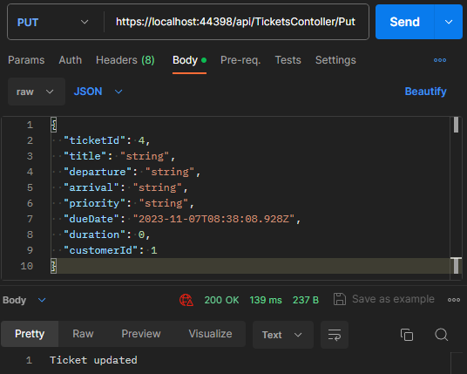

#### Deleting

DELETE by ID: to delete the ticket by ID

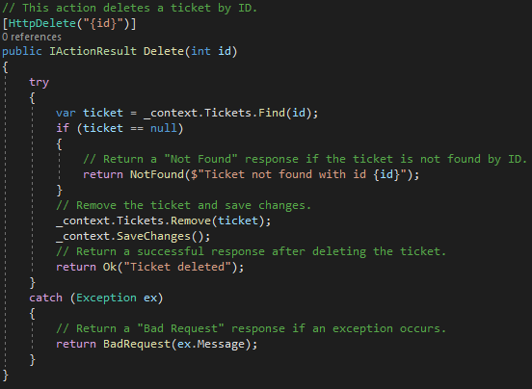

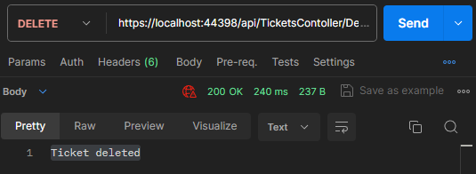

The functionality of the API can also be tested using Swagger by running the API project and executing all the available HTTP methods. This provides a convenient way to interact with and test the API endpoints.

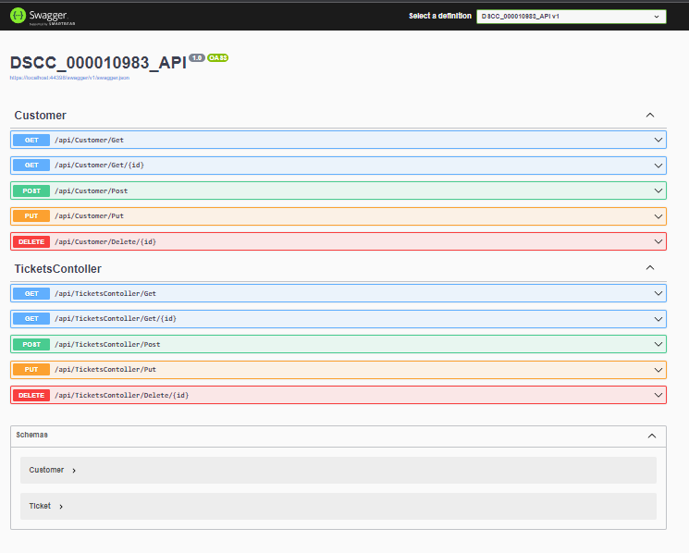

## Package Version Information

While crafting the API microservice, we made use of various packages and dependencies to build the API. At the time of writing, the project was based on the latest stable version of .NET ASP.NET Core, which was version 7. For a comprehensive understanding of the dependencies utilized in this API project, please refer to the accompanying screenshot bellow.

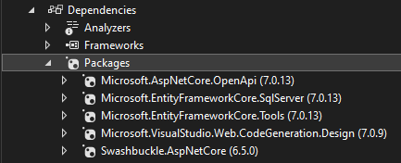

## Database Migrations

Using Microsoft Entity Framework Core Tools, you can create migration files via the Package Manager Console by executing the following commands: "Add-Migration Init" and "Update-Database." The "Add-Migration" command generates a migration with the name "Init" in the migration folder, and the subsequent "Update-Database" command applies the migration to the database specified in your appsettings.json file using the connection string and the ApplicationDbContext class. These properties within the ApplicationDbContext class serve as the definitions for data models that Entity Framework Core maps to database tables, effectively representing those tables in your database and enabling interaction with them in your code. During the data migration process, Entity Framework Core utilizes these DbSet properties to either create or update the corresponding database tables based on your model classes. This facilitates efficient management of your database schema and data structure as your application evolves.

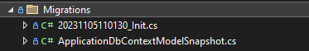

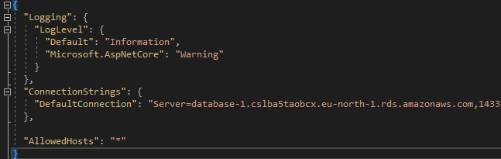

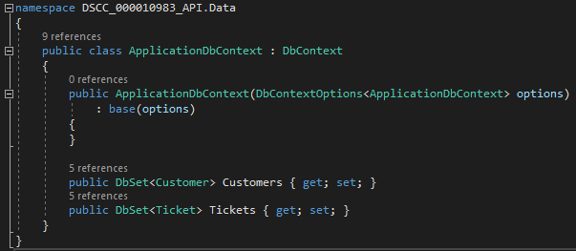

## Stand-alone SQL File with Insert Statements

Tables have been created either by executing SQL queries, as outlined below, or by running the migration file "Init." Subsequently, you can populate both tables with sample data. The first table contains 29 examples, while the second table contains 10 samples, each of which reflects their respective working statuses. I employed the Integrated Development Environment (IDE) of SQL Server Management Studio (SSMS) and successfully connected to the Relational Database Service (RDS) on AWS, as demonstrated in the following sections, where I detailed the steps taken to create the RDS database.

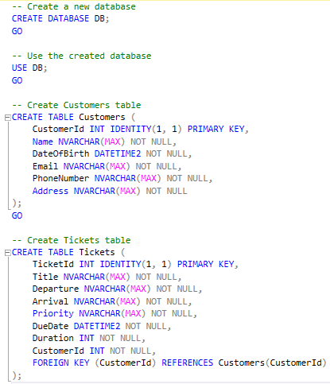

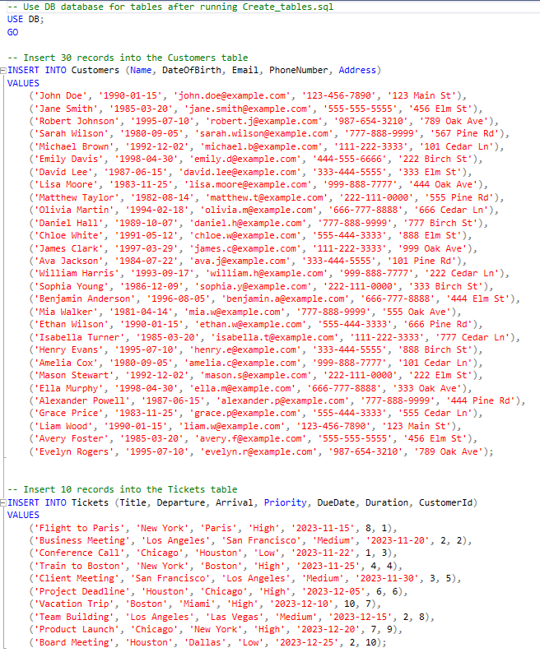

## Database Structure Diagram

The ER diagram, generated within the SSMS’s IDE, illustrates the relationship between the "Customers" and "Tickets" tables. This relationship is established through the use of a primary key (PK) "CustomerId" in the "Customers" table, which serves as a foreign key (FK) in the "Tickets" table. This design ensures data integrity and enables the association of tickets with their respective customers. Additionally, the presence of the "__EFMigrationsHistory" table signifies the usage of Entity Framework. This table maintains a historical record of migrations and their respective versions, making it a crucial component in tracking and managing changes to the database schema over time.

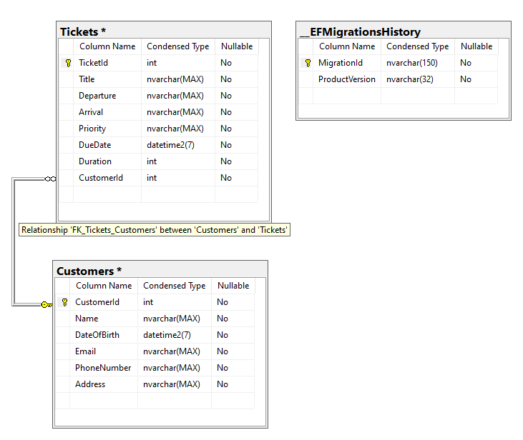

## Screenshots of the Database with Inserted Items

The insertion results displayed in the "Results" section indicate the successful population of the database with the provided data. This confirms that the data insertion process was carried out without issues, and the database now contains the expected information in accordance with your requirements.

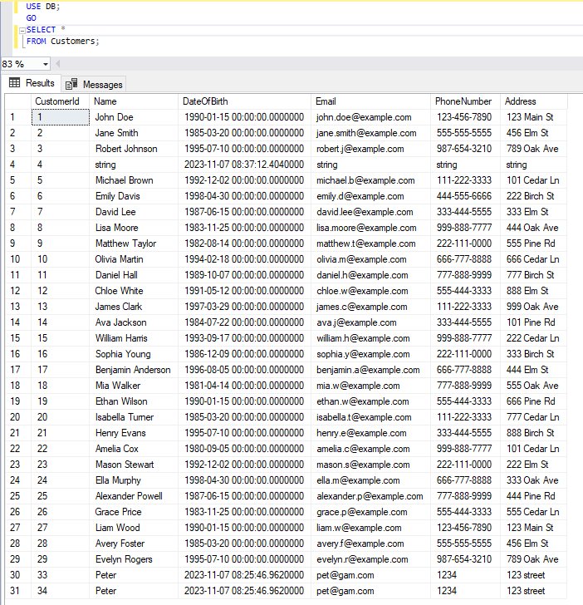

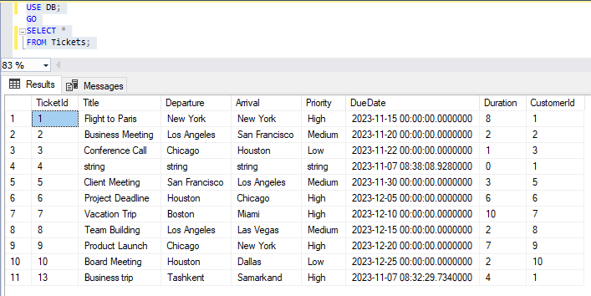

# Version controlling (GitHub).

The project's inception and planning phase began on October 28th, with the initiation of GitHub versioning on October 29th. Subsequently, commits have been made consistently until November 7th, reflecting ongoing development and progress. You can access the project repository and the separate CodeDeploy repositories using the following links below. The commit history, ranging from October 29th to November 7th, is clearly visible in the provided screenshots, underscoring the continuous effort and updates made to the project during this time frame.

## Project Repository

Link: <https://github.com/00010983/CW_DSCC_10983>

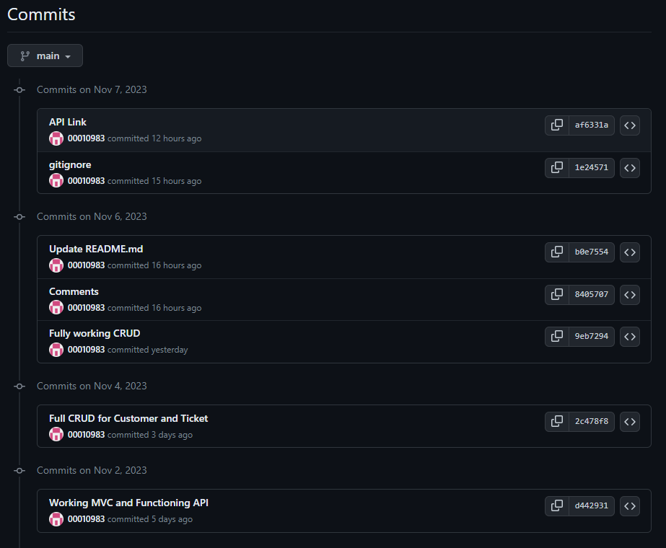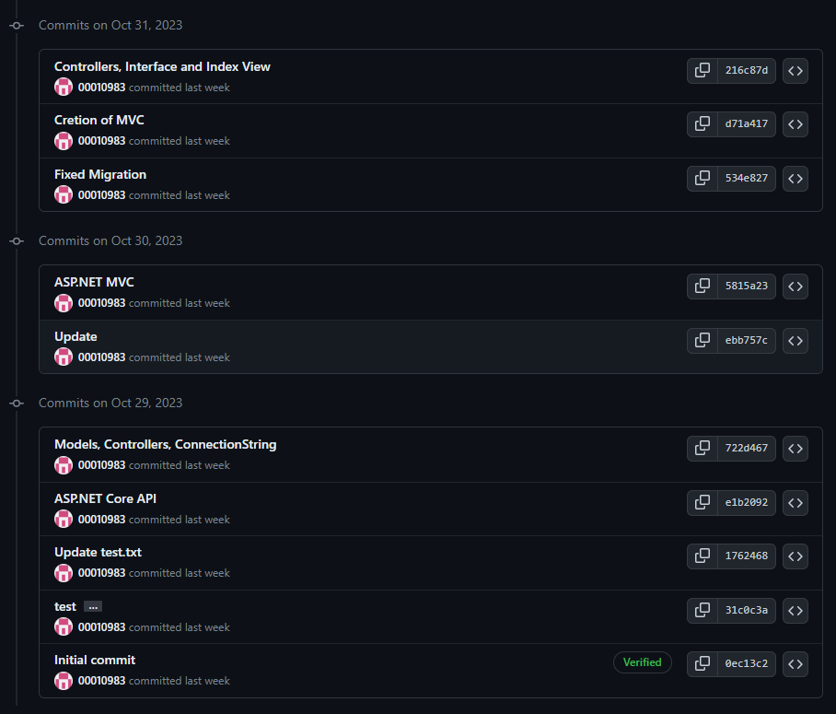

## API Repository

Link: <https://github.com/00010983/API_00010983>

## Frontend (MVC) Repository

Link: <https://github.com/00010983/MVC_00010983>

# Hosting and Code Deploy.

## Code Deploy Service Role

Creation of the AIM CodeDeploy Service Role for our instances deployment group creation.

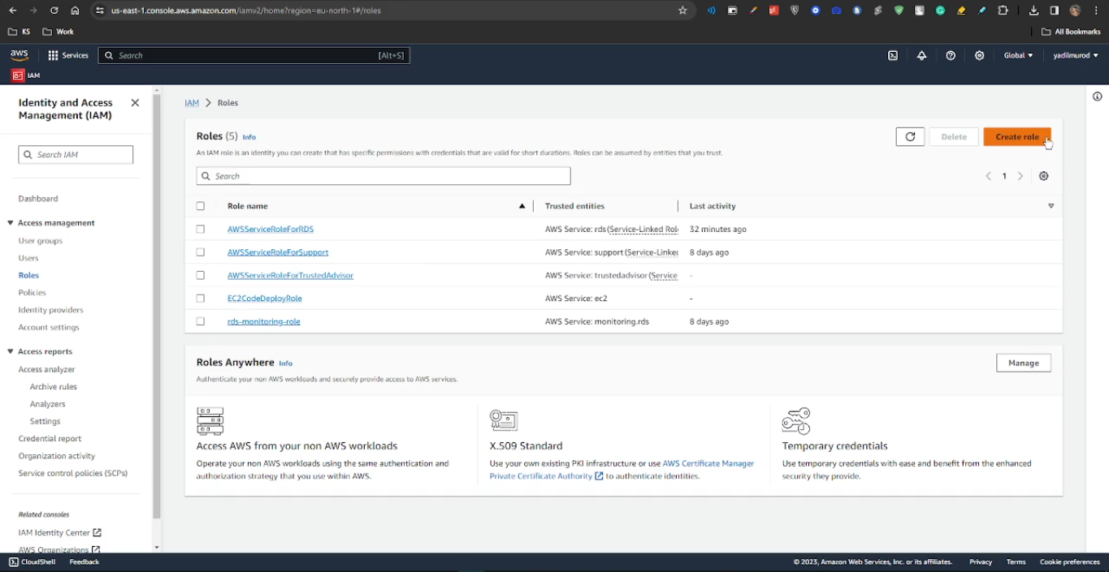

We selecte the trusted entity type, AWS service is the choice, and for the use case, the option chosen is CodeDeploy. After making these selections, we can proceed to the next step in your AWS configuration.

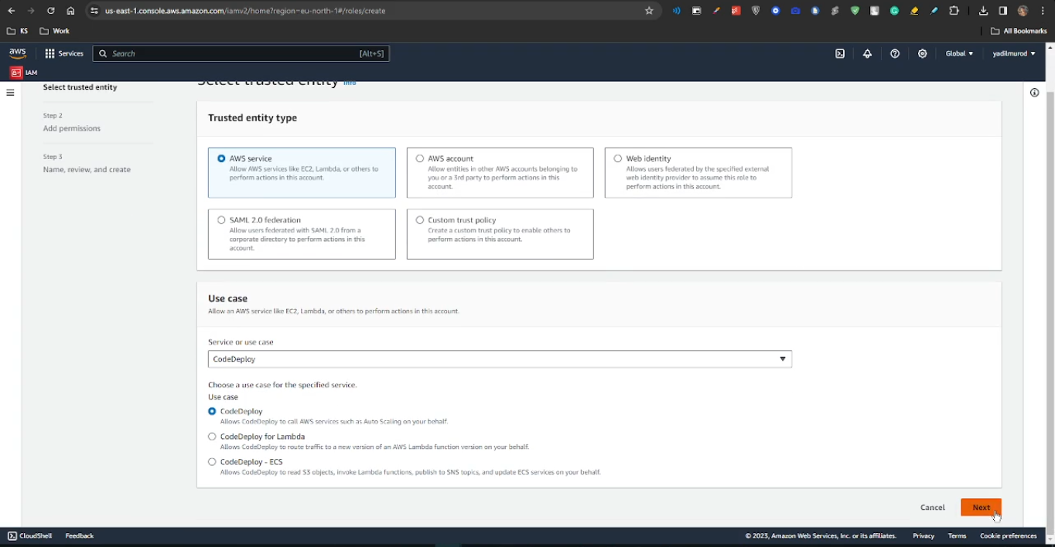

We are directed to provide a name for your CodeDeploy Service Role. After naming it, we can proceed by clicking "Create" to generate the service role without making any further modifications. This step finalizes the creation of the role necessary for CodeDeploy service functionality.

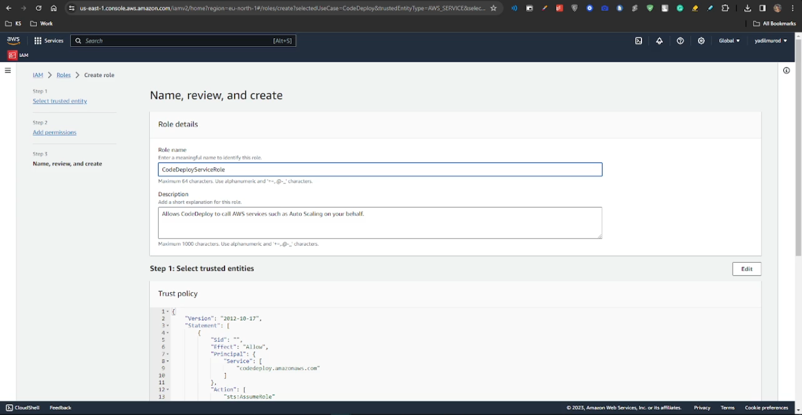

## Database Server Setup

We have created our RDS database in AWS.

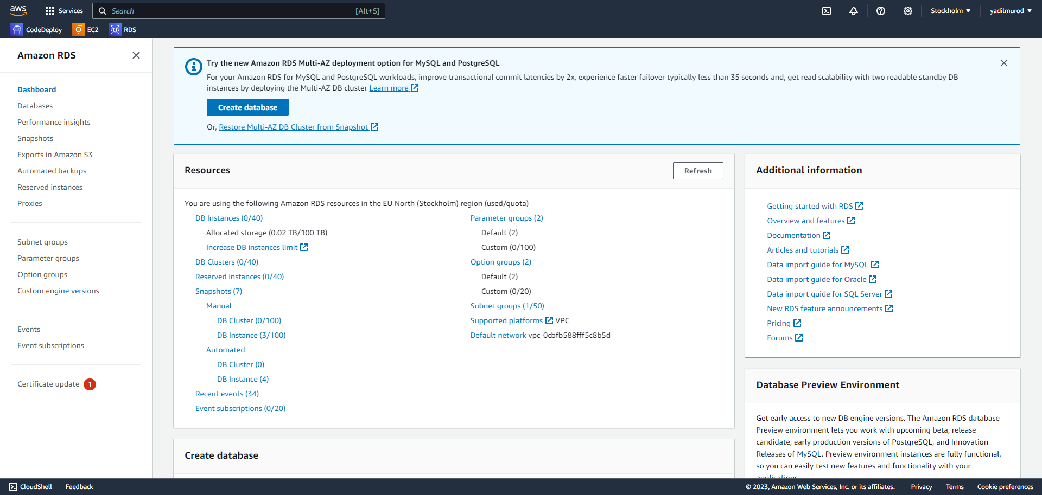

For our project we select SQL server, and use Standard create option.

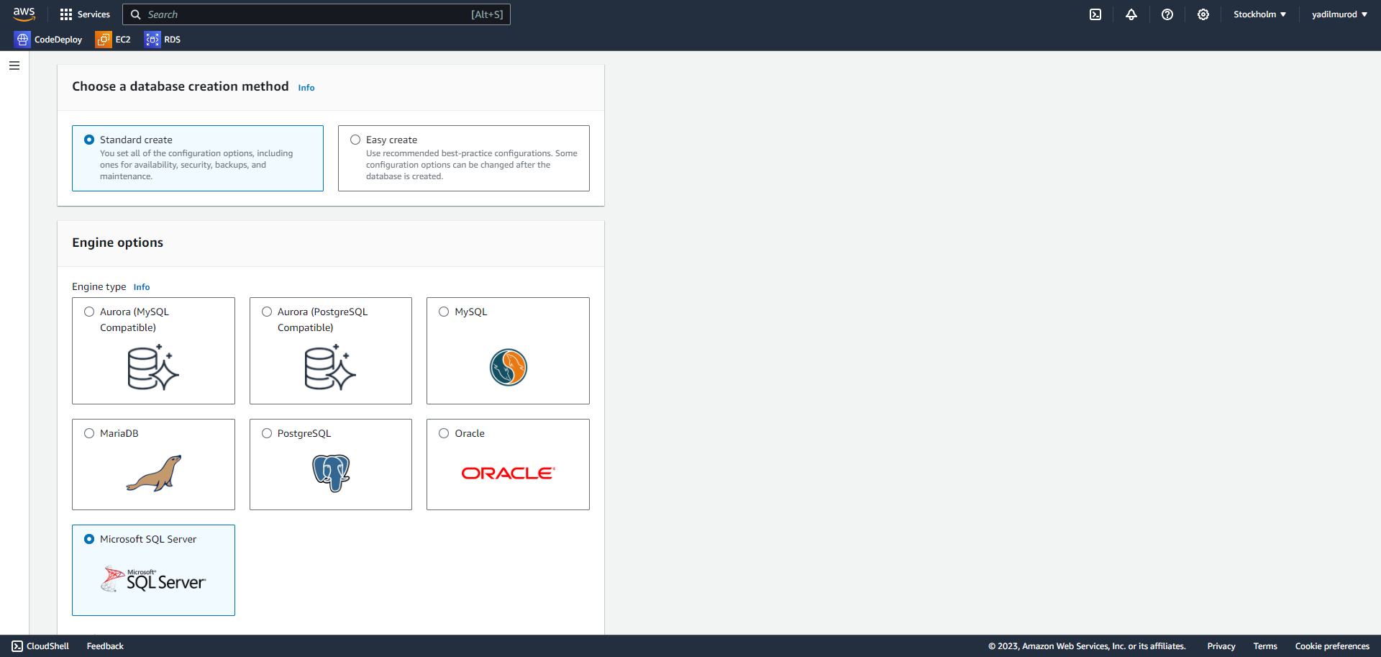

For our Template we use the Free Tier options from the given ones.

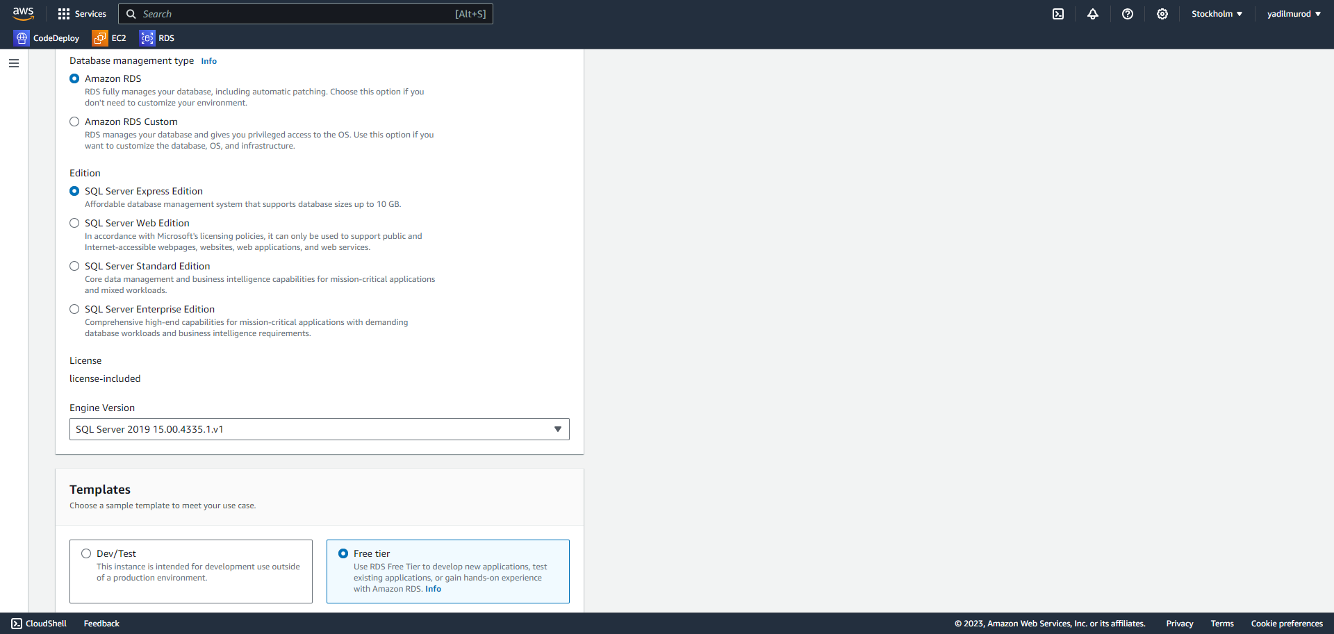

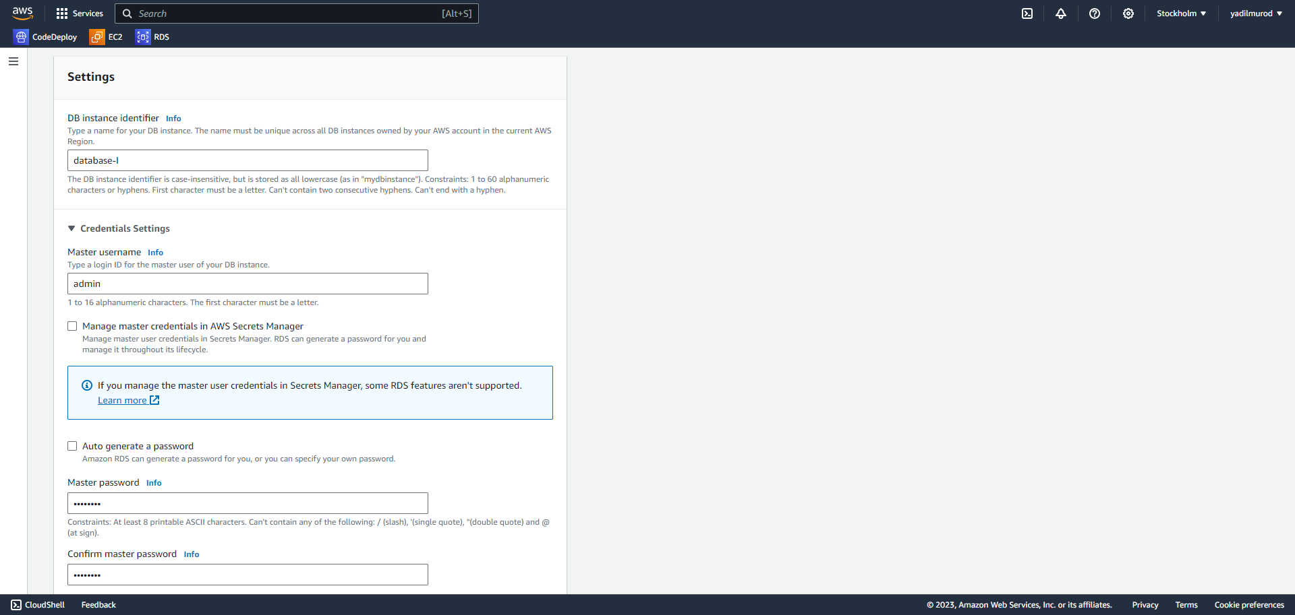

The default database name remains as "database-1," and the default username is "admin," which will remain unchanged. The password has been set to "12345678," and we will use it for our API connection string in the future.

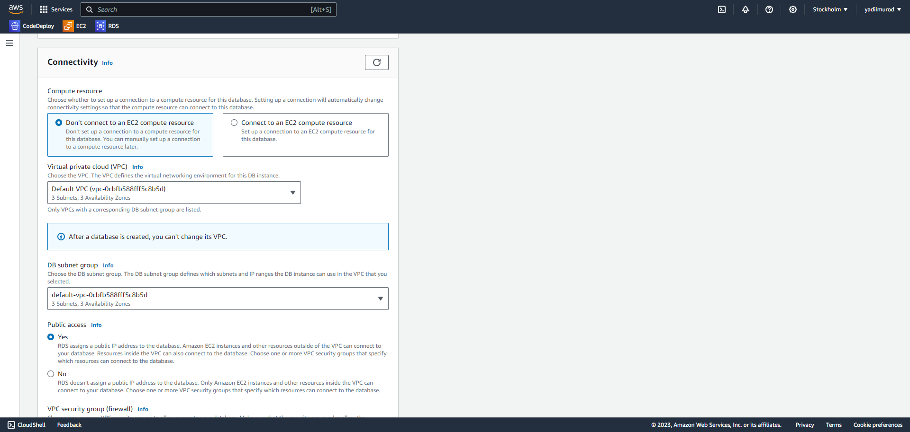

We have enabled “Public” access and successfully created our database. As shown below, the database has been created and is currently running.

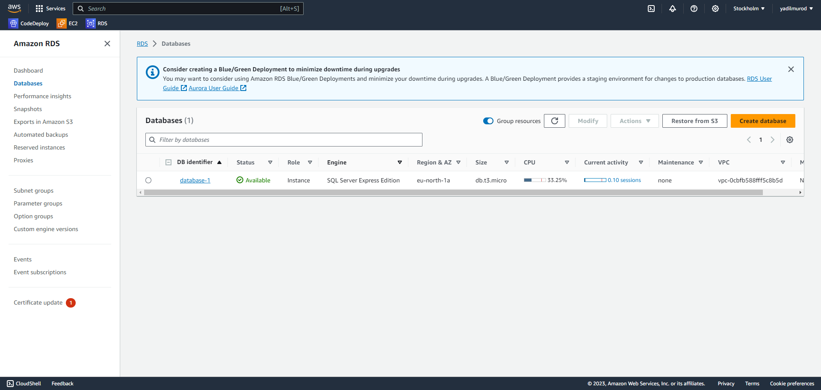

We retrieve the configuration details of the database and copy the Endpoint and port number for future use.

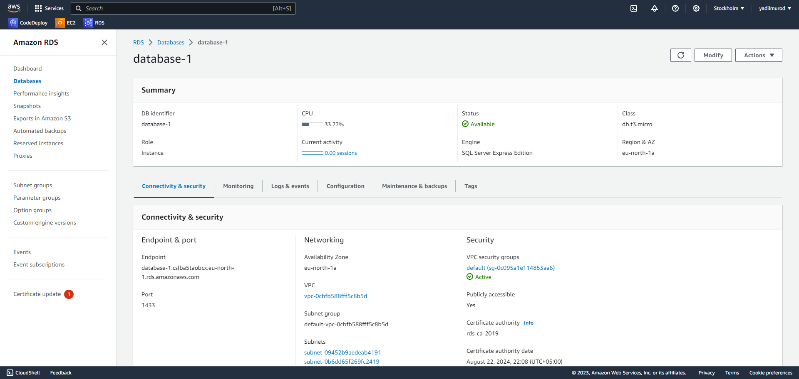

We modify our security group settings to enable access to our database using MSSQL port 1443 from any source. Additionally, we create an additional security group to allow access to our database from other connection strings.

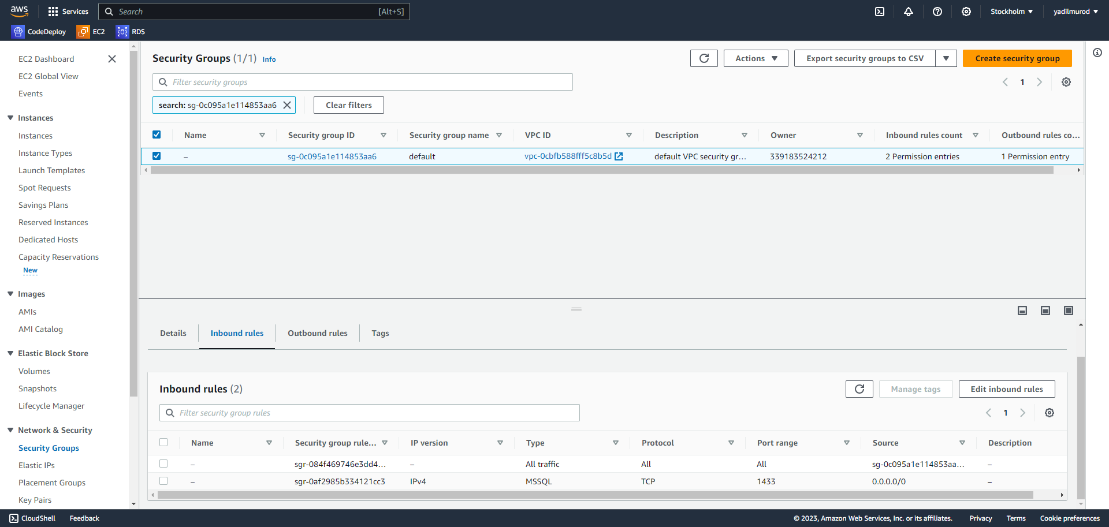

With the obtained endpoint and port number, we can now edit our connection string for the ASP.NET API project, as demonstrated below, to establish the connection with the RDS database in appsetting.json file of the project folder.

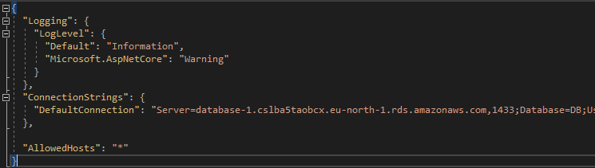

## Linux Instance Setup

We can now proceed to create our Linux API instance for our project. In the following screenshots, we will navigate to the EC2 section, locate the "Launch Instance" option, assign a name to our instance, and select Linux as the operating system for our instance.

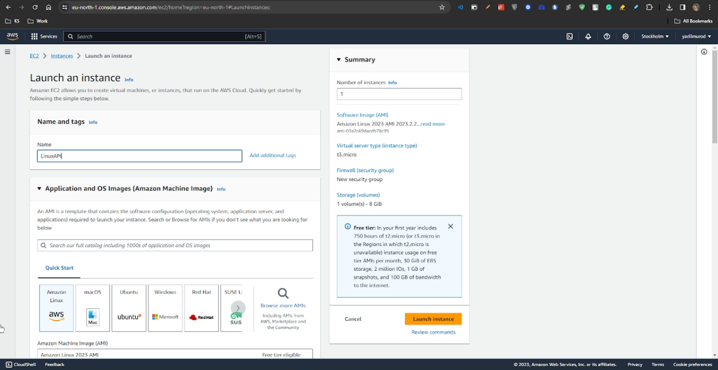

We create the new KeyPair and store it on our PC.

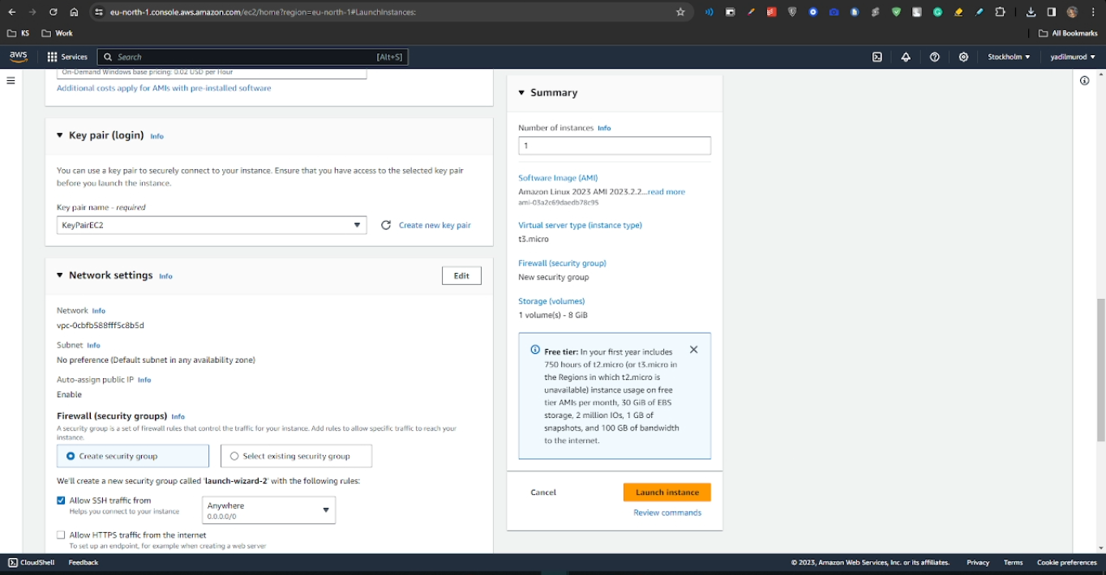

We will configure all the necessary options within the Security Group to ensure smooth internet access to our API in the future.

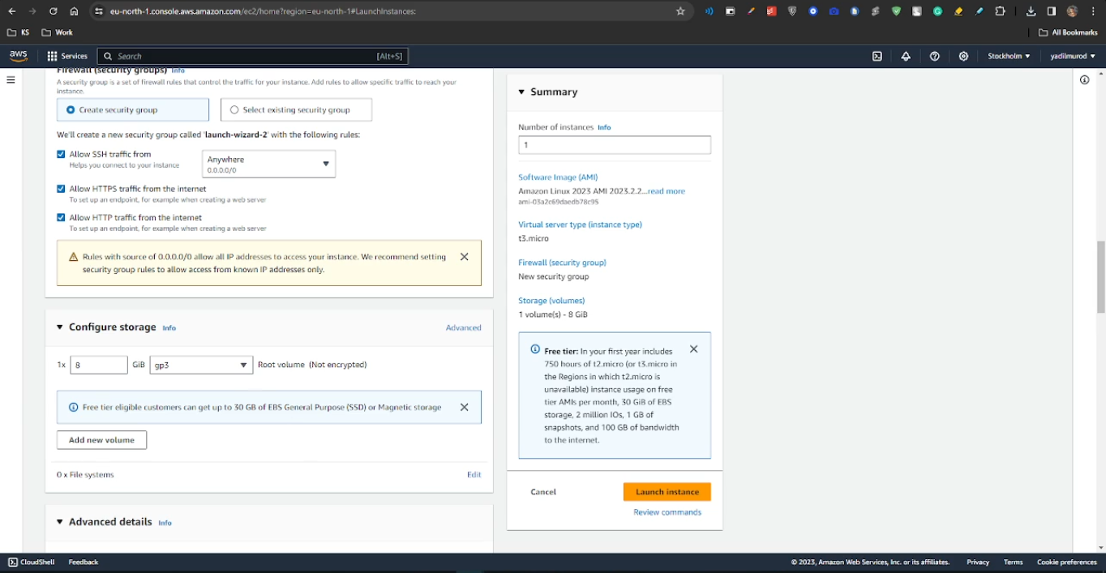

We select our IAM instance profile which we created before.

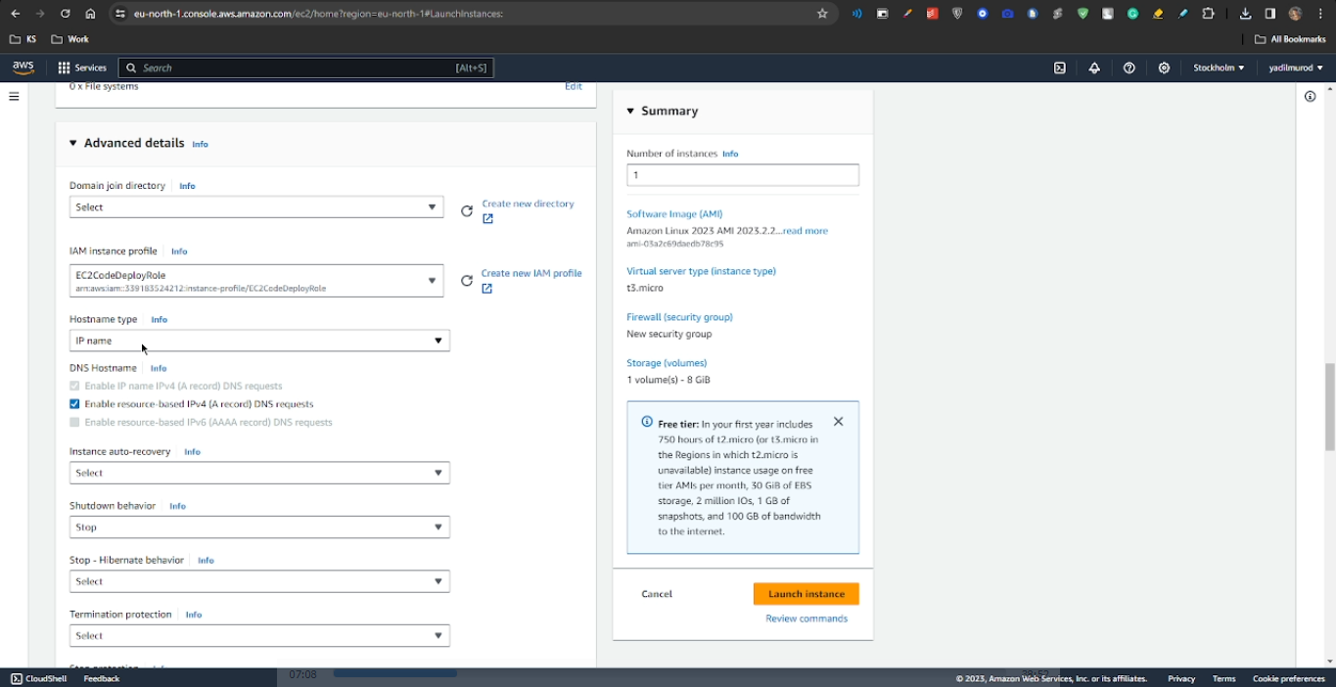

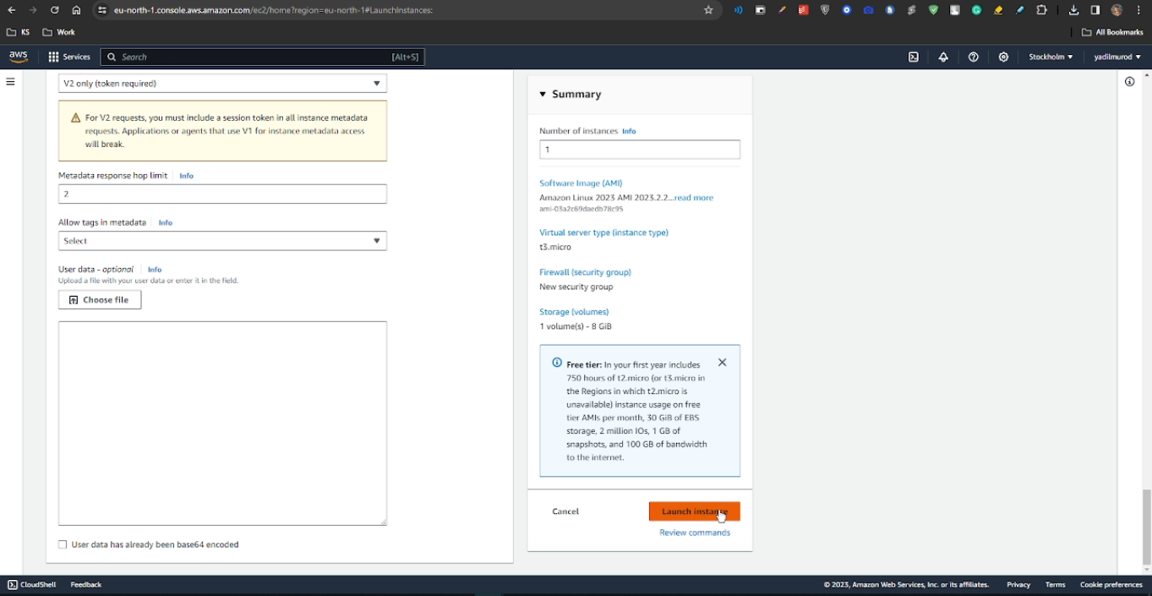

After the creation of our instance, we will proceed with the configuration of our connection settings.

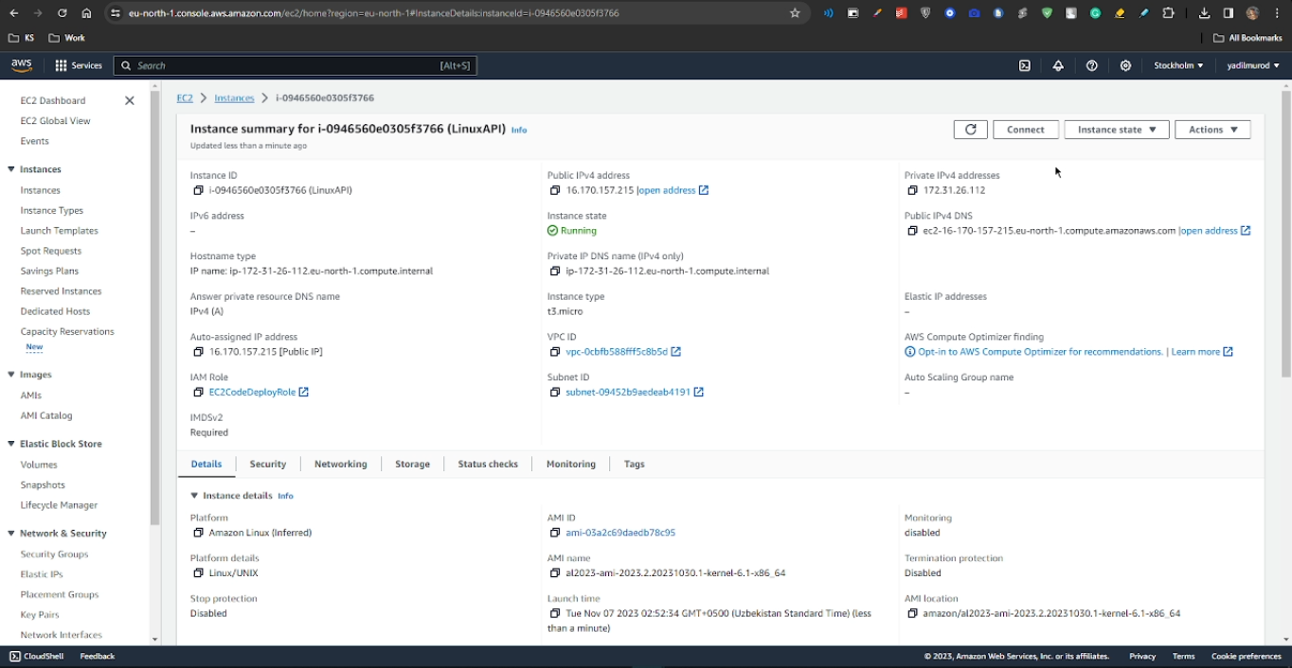

After that, we will access our instance using an SSH client, such as Git Bash, and execute the following commands:

1. sudo yum update
2. sudo yum install ruby
3. sudo yum install wget
4. sudo rpm -Uvh https://packages.microsoft.com/config/centos/7/packages-microsoft-prod.rpm
5. sudo yum install aspnetcore-runtime-7.0
6. dotnet --info
7. cd ~/
8. pwd
9. wget https://aws-codedeploy-eu-north-1.s3.eu-north-1.amazonaws.com/latest/install
10. chmod +x ./install
11. sudo ./install auto
12. sudo service codedeploy-agent status

These commands will help us set up the necessary environment and services for our instance.

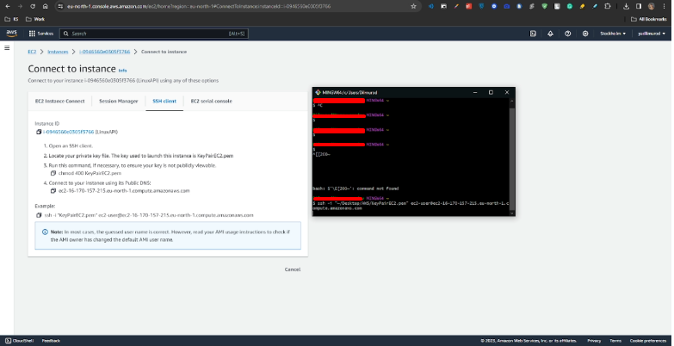

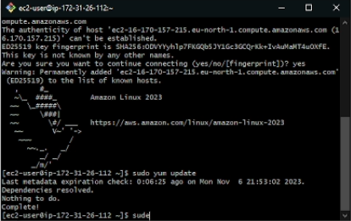

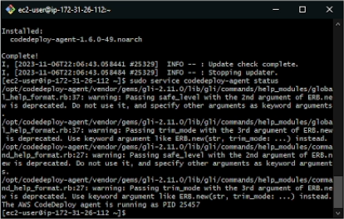

Upon completing the aforementioned steps, we can observe that our CodeDeploy agent is running with PID 25457. With this in place, we can now proceed to create our application. We will assign a name to it and select the compute platform as EC2.

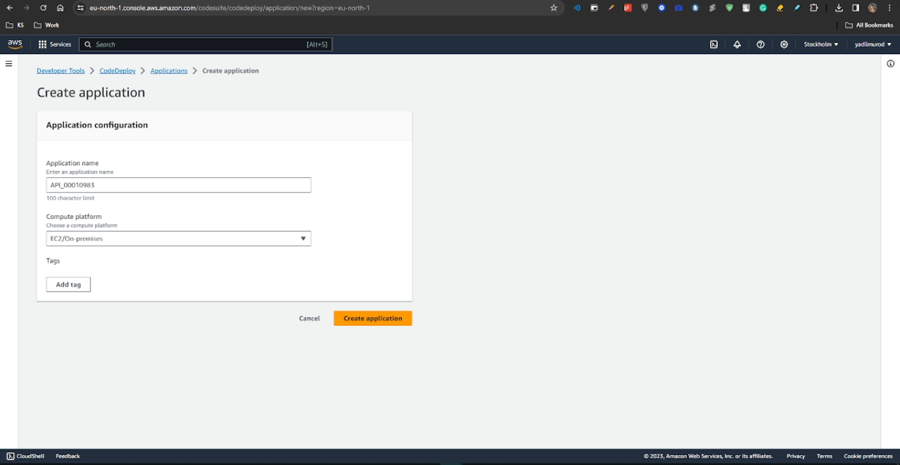

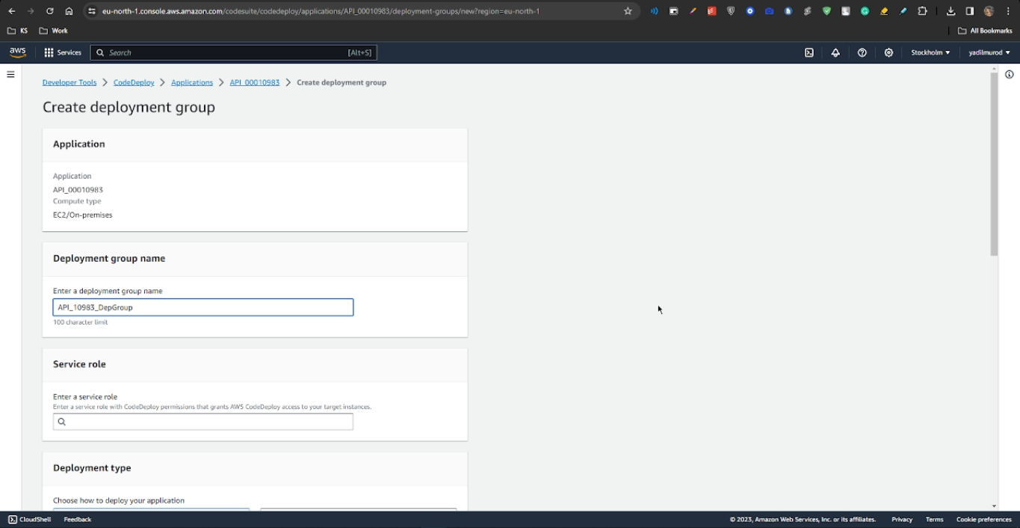

Next, we will provide a name for our Deployment group and select the instance we previously created for the "Value" field.

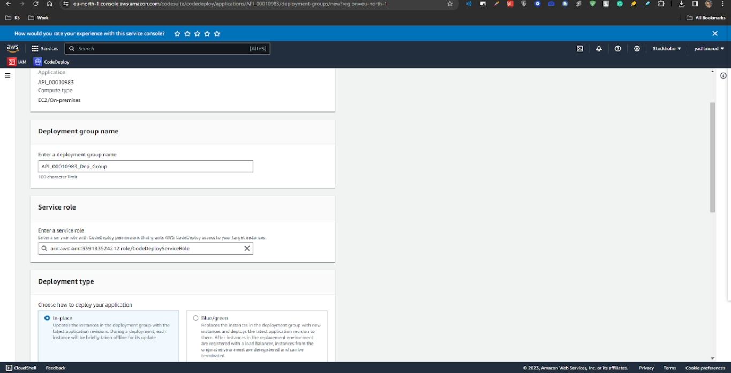

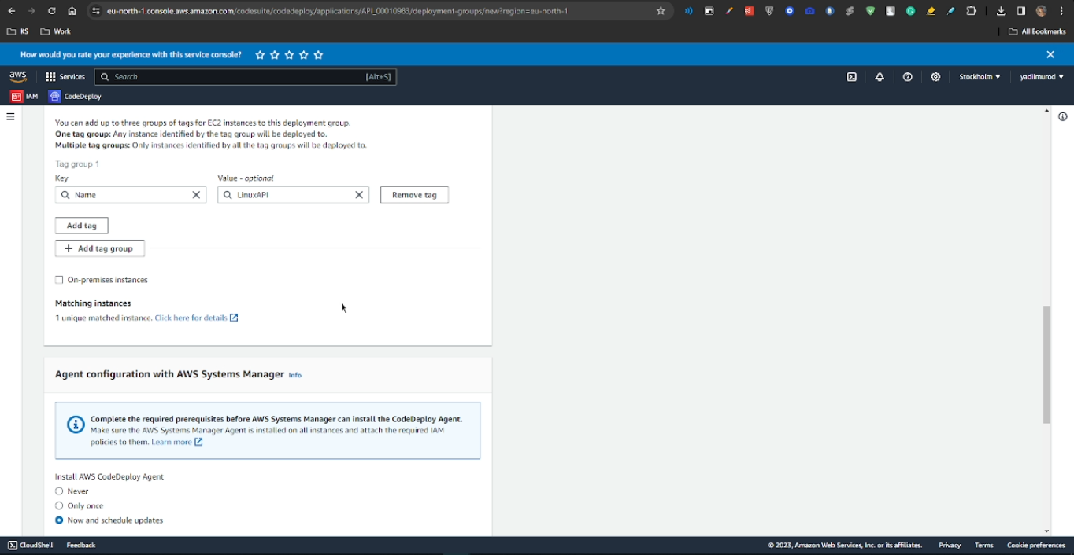

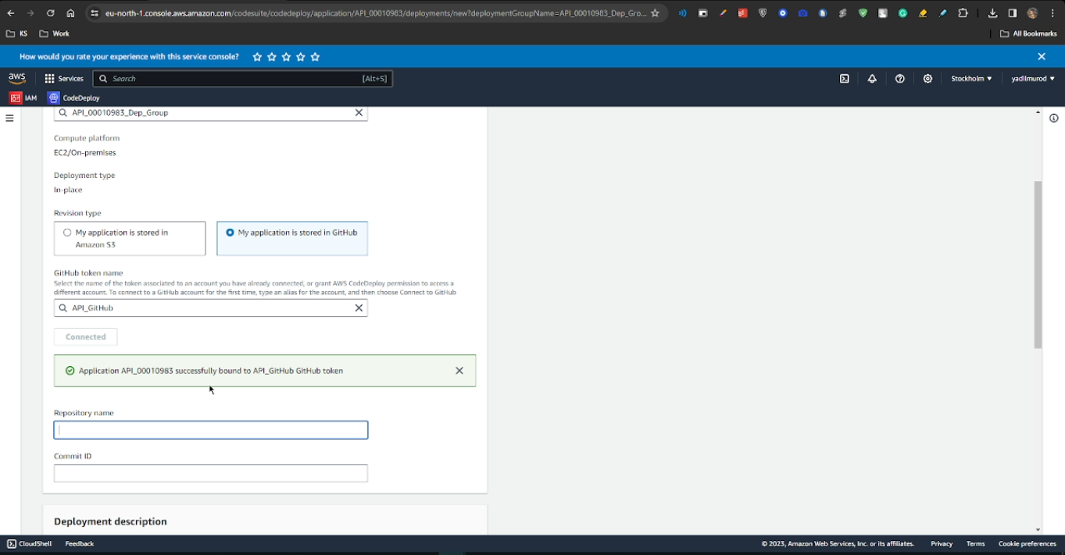

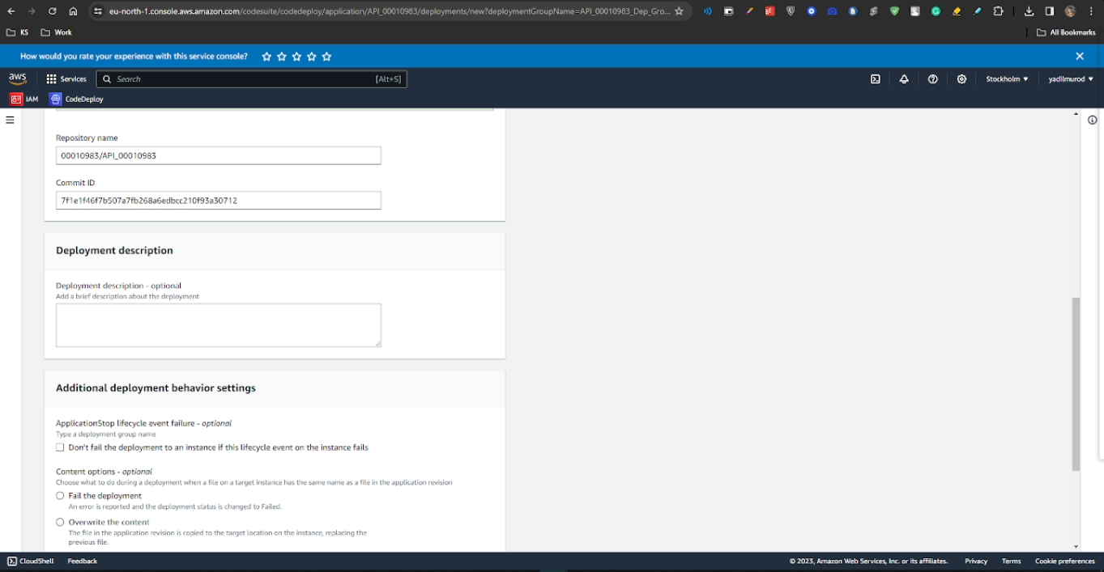

Once we have successfully connected to our GitHub repository and selected the specific commit hash, we can proceed to the next sections, and check the specified boxes below as on the screenshot.

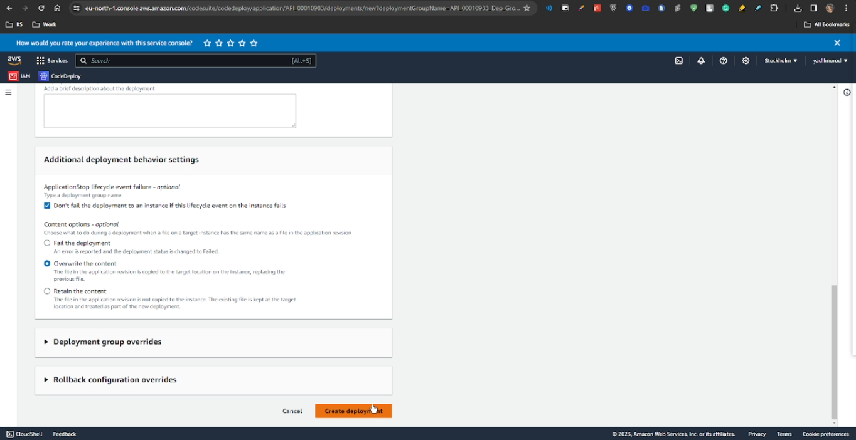

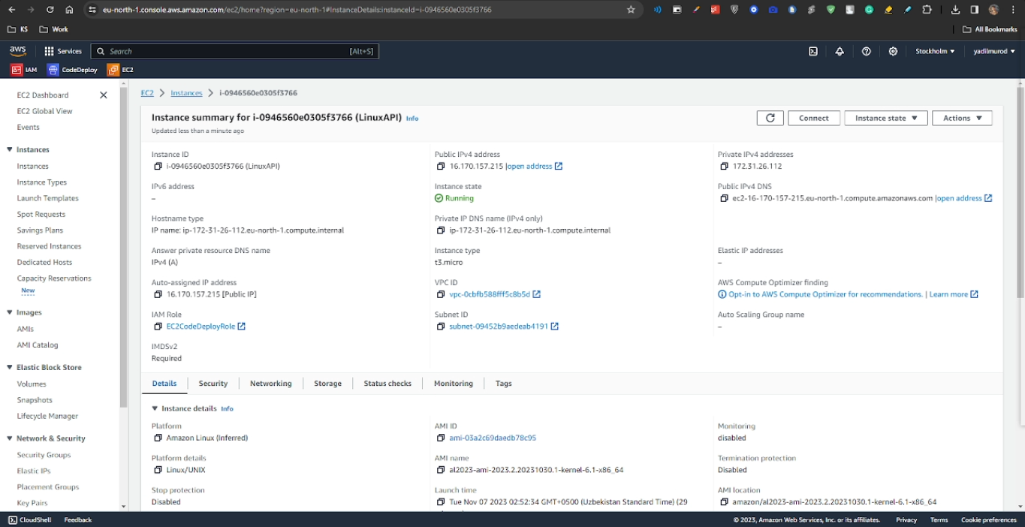

Having created our instance, we can now access it using the Public IPv4 DNS link provided.

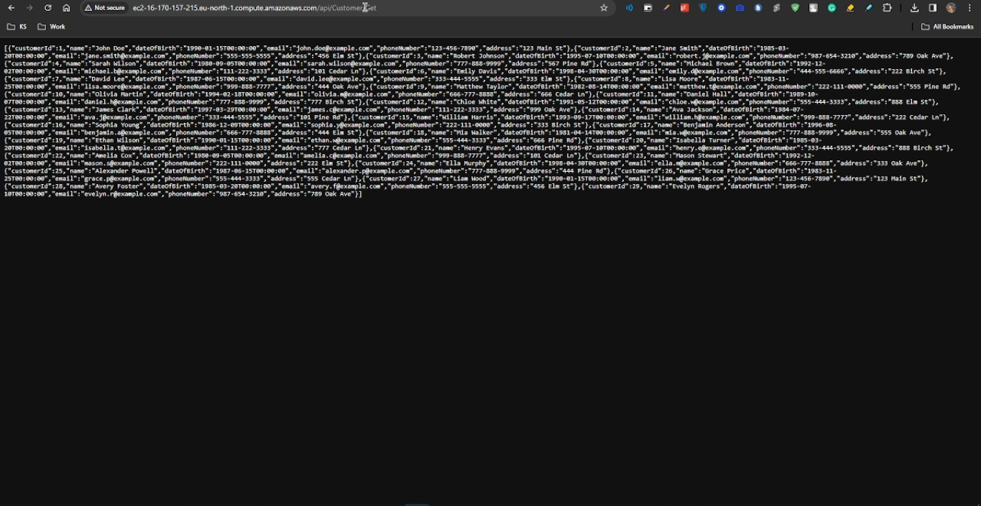

## Microsoft Instance Setup

After successfully testing our API using the above-mentioned link, we can proceed to configure our MVC project with new HTTP methods and links, as illustrated below.

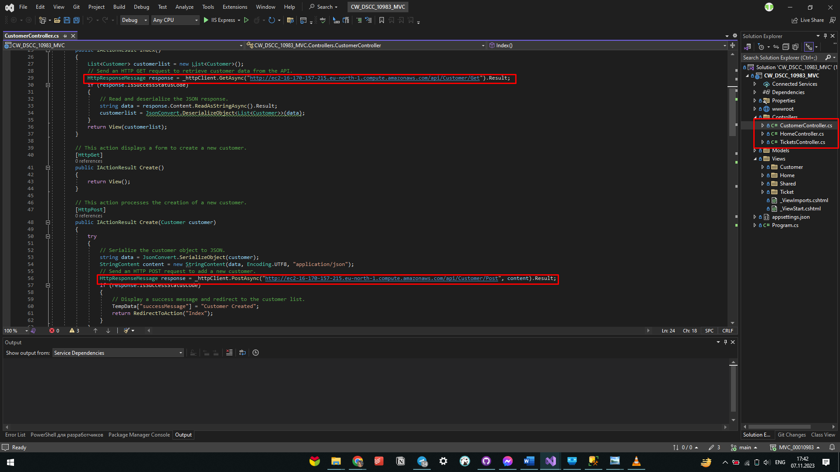

We will now create a Windows instance for our MVC project. During this process, we will name our project and select Windows as our operating system.

## 

We create and choose our KeyPair.

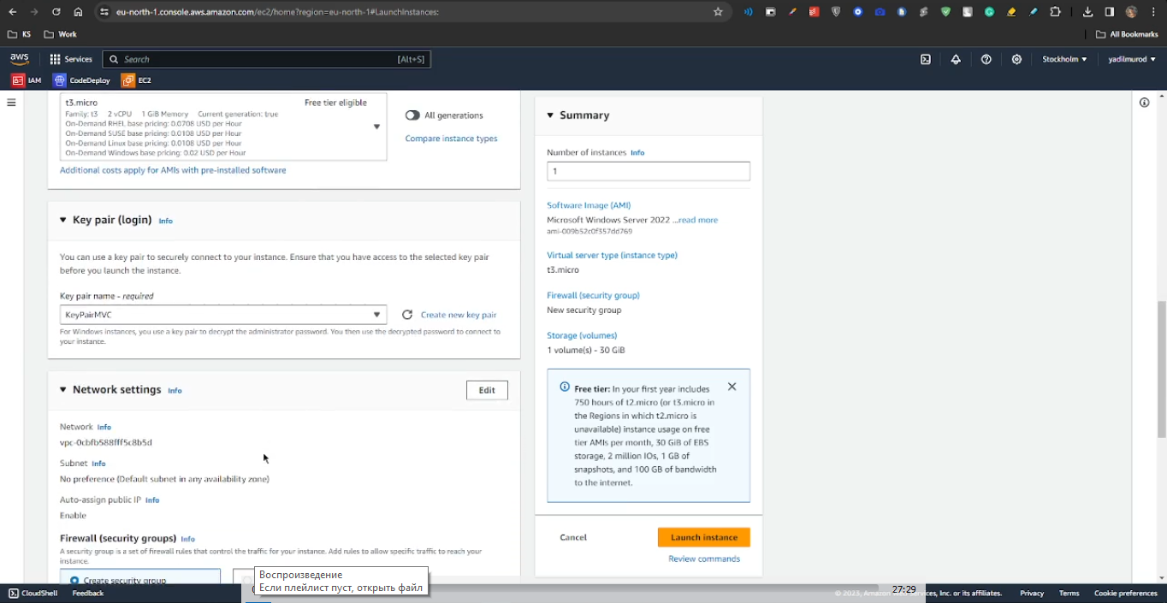

We check all security group boxes.

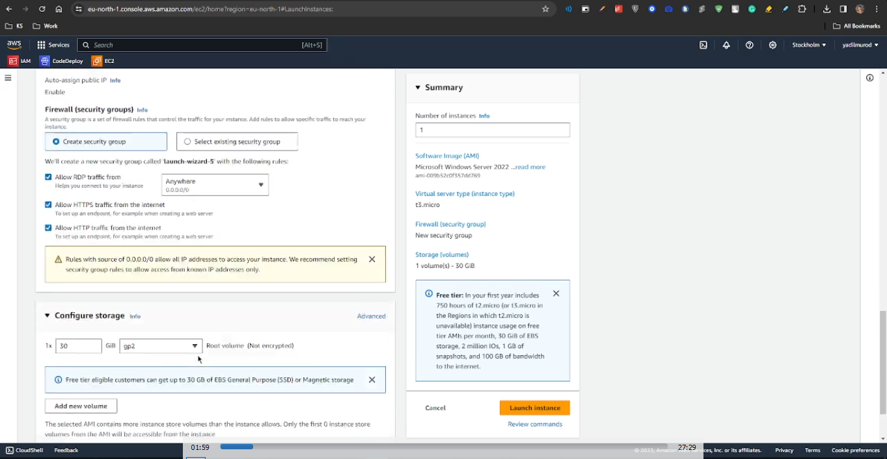

After choosing IMA instance profile we can launch our instance.

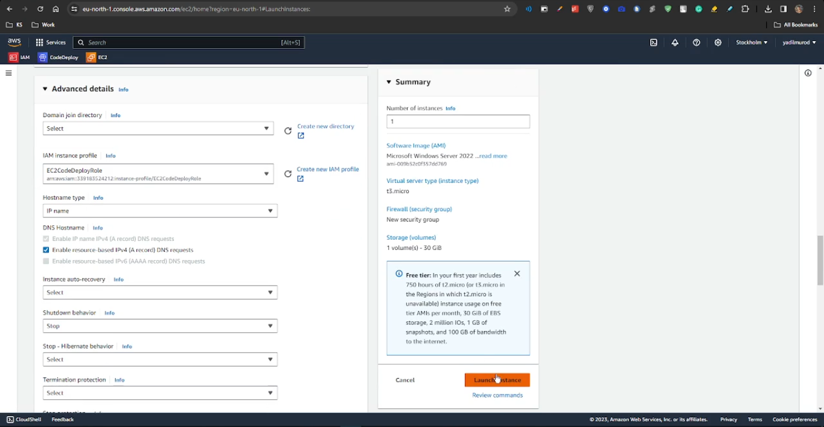

In the next step, we will access our instance configurations and proceed with the "Connect" option. This will allow us to download our virtual machine on our PC and install all the necessary packages.

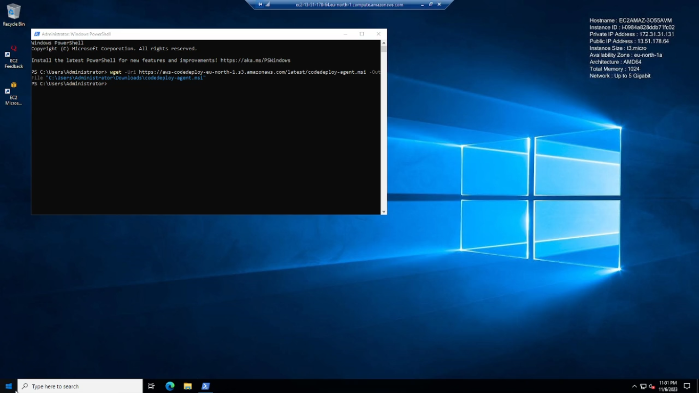

After downloading the "codedeploy-agent.msi" file using the command in the command line: wget -Uri https://aws-codedeploy-eu-north-1.s3.amazonaws.com/latest/codedeploy-agent.msi -OutFile "C:\Users\Administrator\Downloads\codedeploy-agent.msi", we can proceed to open the MSI file. Once open, we will add roles and features, add the necessary packages, and initiate the installation process.

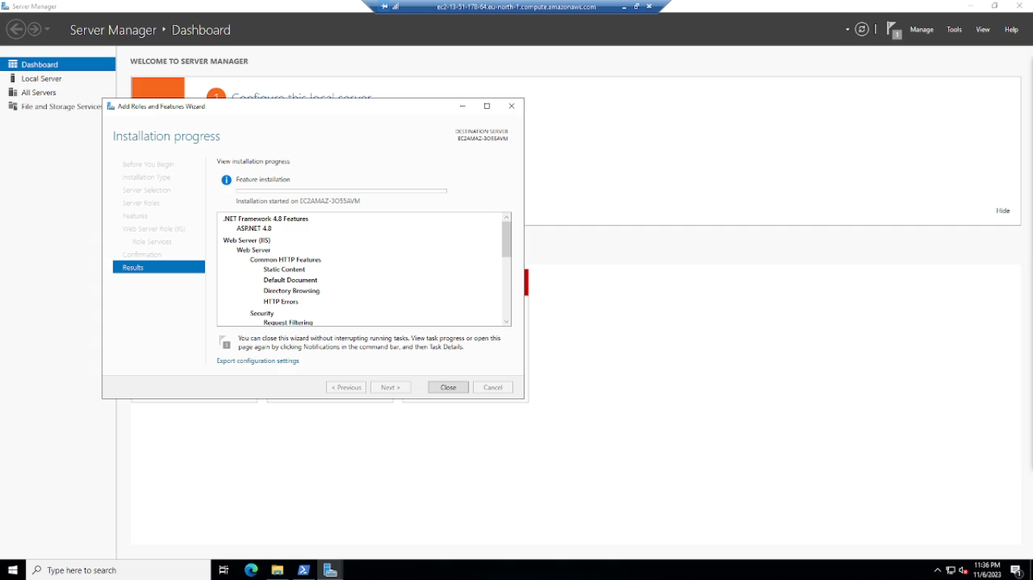

Subsequently, we will proceed to download and execute the hosting bundle from the provided link: https://dotnet.microsoft.com/en-us/download/dotnet/7.0

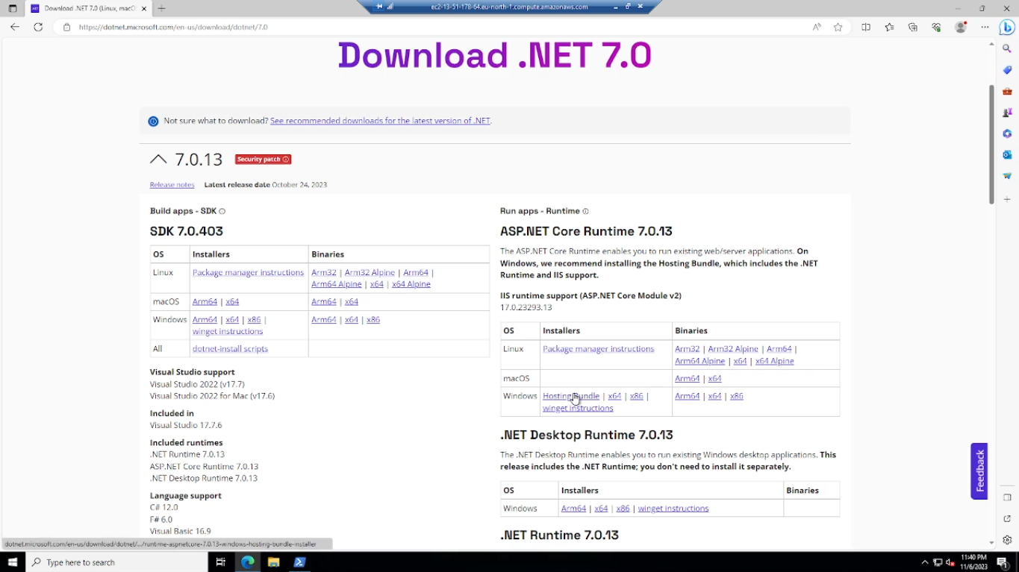

Now, we can proceed to create our deployment group, following the same steps as we did for the Linux instance. The screenshots below illustrate the necessary steps to complete the deployment group creation.

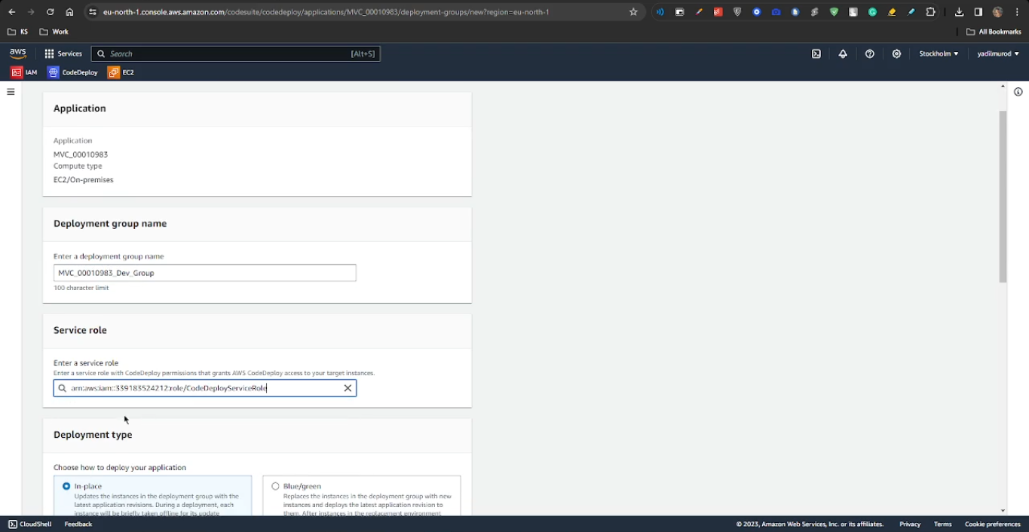

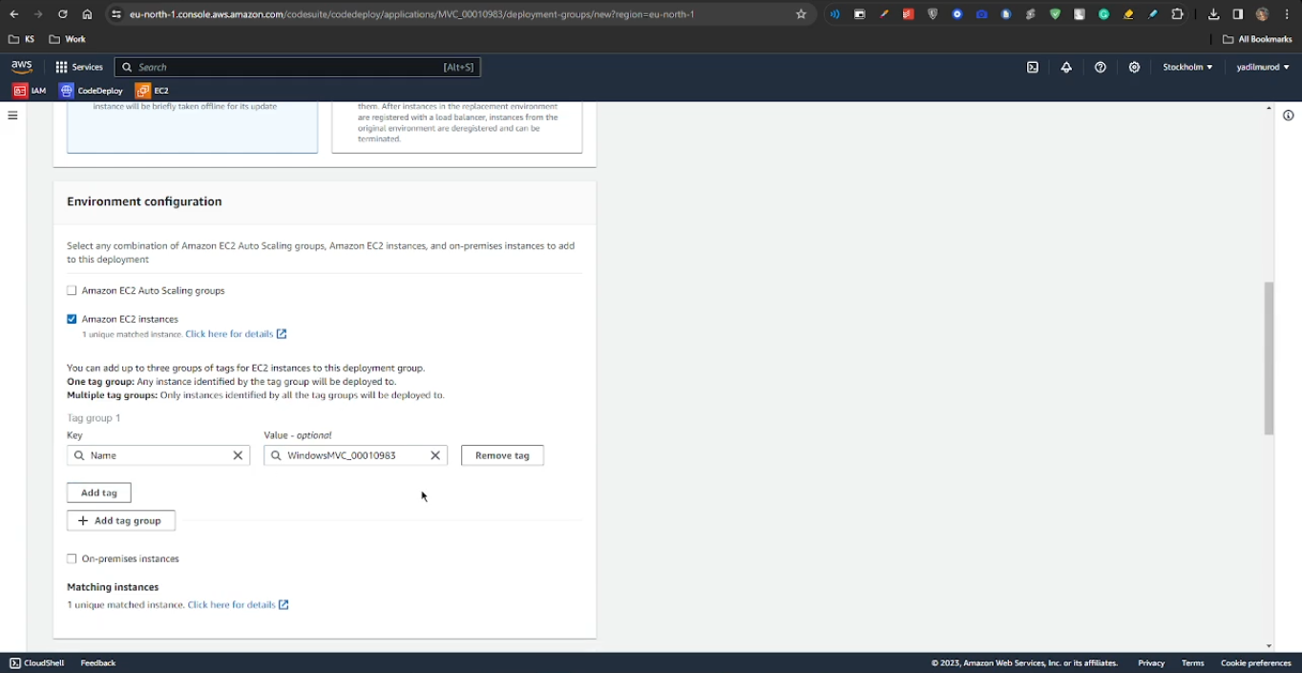

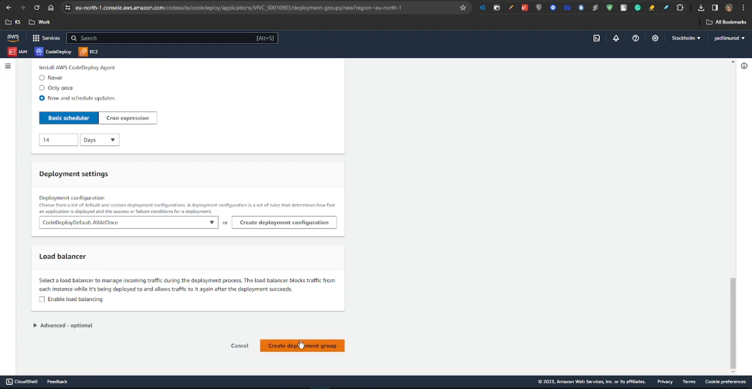

Here, we will connect to the GitHub repository we created in the previous steps and use the latest commit hash to continue our deployment process.

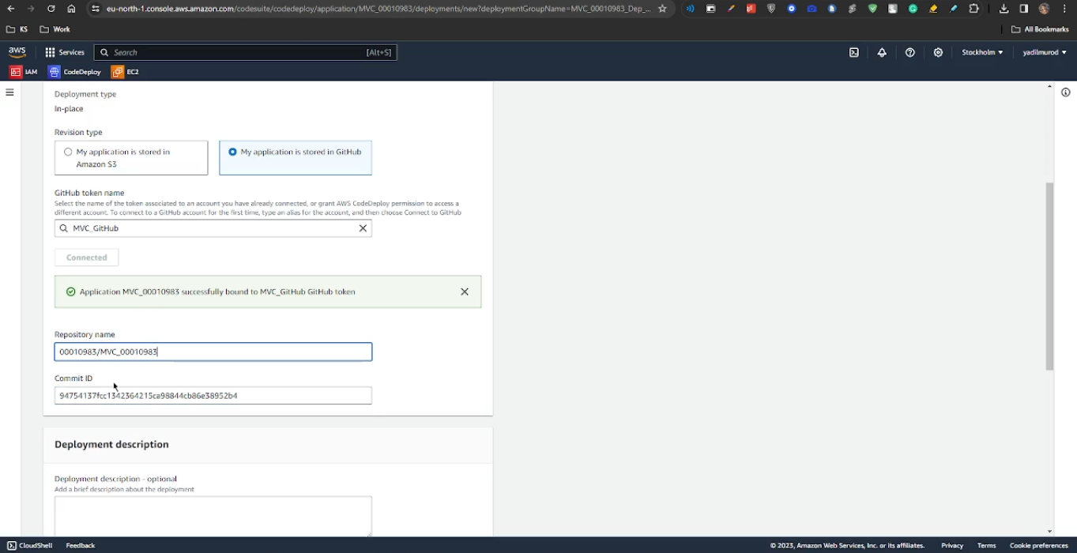

We check the same boxes as shown in the screenshot below and create the deployment.

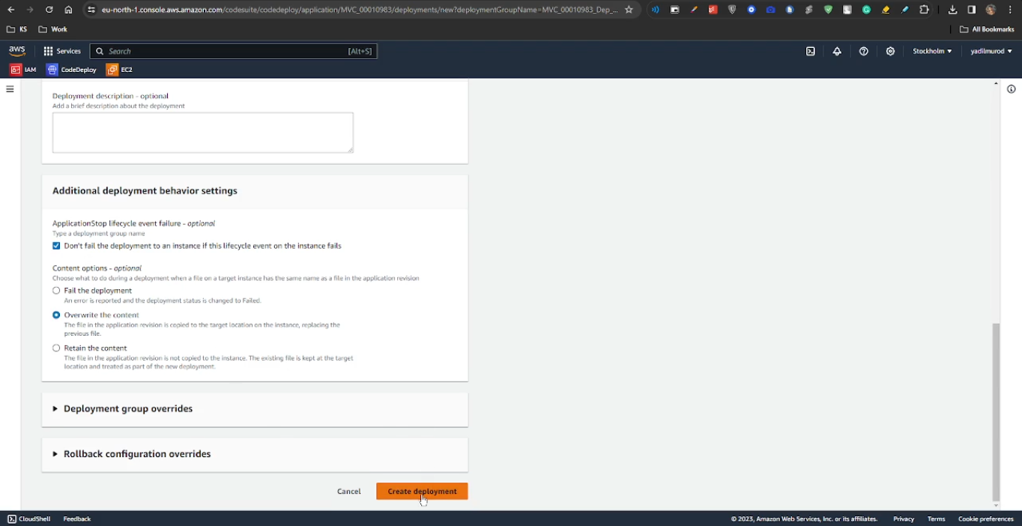

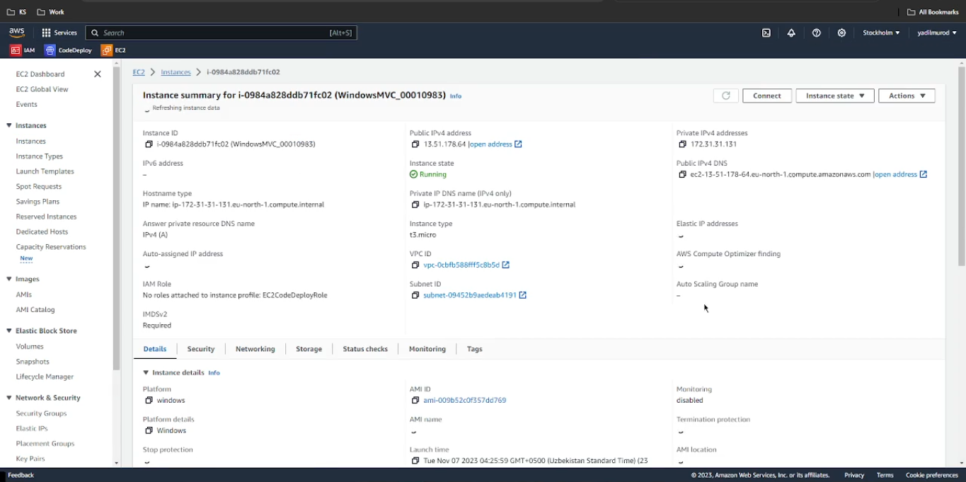

With the successful creation of our Windows instance for the MVC application, we can now access our project using the Public IPv4 DNS provided.

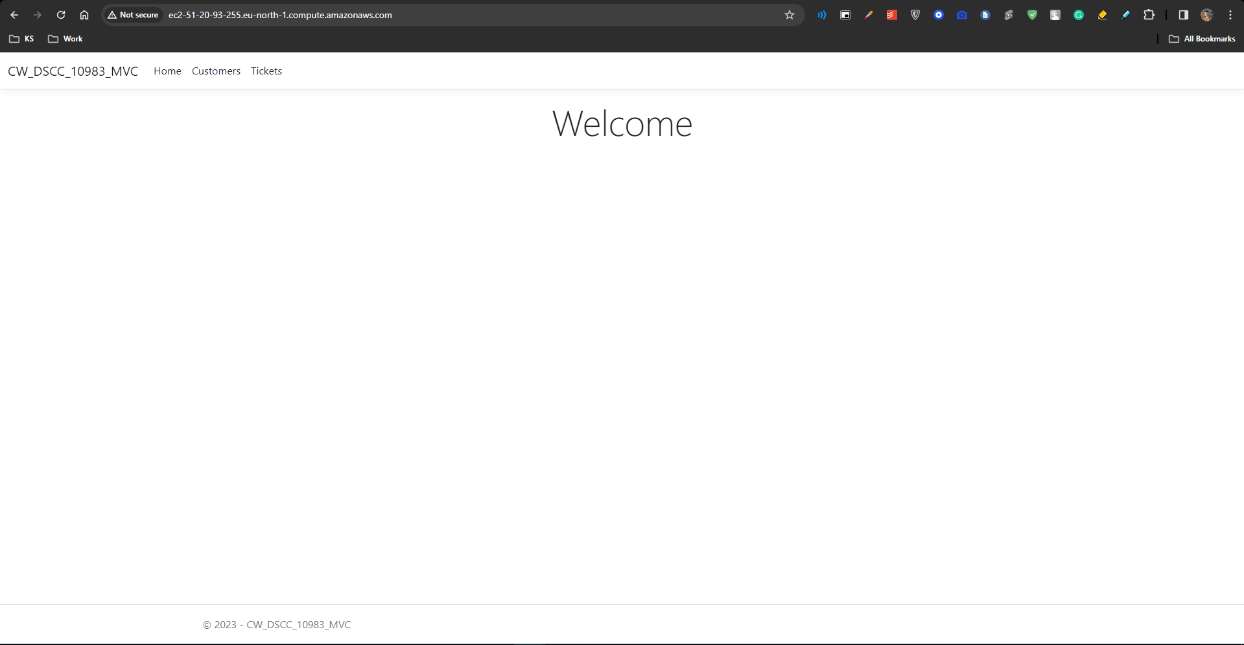

# Conclusion

In summary, this report has documented the structured development and deployment of a full-stack web application using contemporary frameworks and cloud services. The project demonstrated skills in planning, building APIs and UIs, source control, and cloud deployment. While opportunities exist to expand features and enhance security, the application serves as a valuable hands-on learning experience for full-stack development. The report has detailed the combination of MVC, ASP.NET Core API, AWS, and other technologies to create a functional data-driven web application.